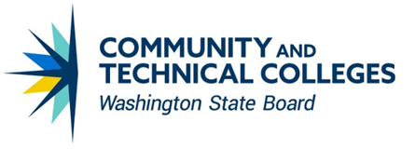


Guided Pathways Practices
WAshington STudent Success Center

Table of Contents
Table of Contents 2
Introduction 2
Guided Pathways minimum requirements 2
Using this document 2
Section 1: Pathway and Program Design 3
Programs of study 3
Program maps 3
Annual course calendar 3
Class scheduling based on student data 3
Section 2: Pathway Entry and Navigation 4
Academic and career exploration and program choice 4
Advising and educational planning 4
Progress monitoring 4
Section 3: Teaching and Learning 5
Enriched instruction in program foundation courses 5
Corequisites and aligned academic support 5

Introduction
In 2019, the Washington State Legislature passed the Workforce Education Investment Act, providing funding to all 34 community and technical colleges to implement Guided Pathways, a framework designed to create structured support for students from enrollment to completion.

Guided Pathways minimum requirements
Guided Pathways minimum requirements are outlined in RCW 28b.50.925. A summary is provided below.
- Comprehensive mapping of student educational pathways with student end goals in mind.
- Dedicated advising and career counseling that helps students make informed program choices and develop completion plans.
- Data analysis of student learning as well as program and service outcomes.
- Inclusive curriculum and teaching practices.

Using this document
This document provides an overview of the focus areas and practices related to Guided Pathways implementation. As you use this document, please consider how each of these areas and practices intersects with others in the framework and how your role can and/or does contribute to transforming the student experience in service of completion and success.
For more information about Guided Pathways in Washington, including resources and professional development opportunities, visit the website for the Washington State Student Success Center.

Section 1: Pathway and Program Design
This area focuses on comprehensive mapping of student educational pathways with student end goals in mind. Minimum Guided Pathways implementation includes transparent and clear career paths that are tightly aligned to the skills sought by employers. Pathways must align course sequences to show clear paths for students, alignment with K-12 and university curriculum, and skill sets needed to enter the workforce.

Programs of study
Programs are well designed with clearly defined learning outcomes aligned with industry identified needs and transfer pathways. Course outcomes are aligned with program and pathway outcomes, and those learning outcomes inform a default course taking framework.

Predictive courses
For each program of study, key courses in addition to math and English have been identified that are predictive of student success in completing that specific program. Instructors can then develop specific strategies and support systems within those courses to make them more inclusive and accessible to all learners. Advisors also use the information to help students make informed selections and/or transition between programs of study.

Math pathways
Required math courses have been identified that are appropriately aligned and contextualized to each program of study.

Program maps
Programs are clearly mapped to guide and prepare students to enter employment and/or further education regardless of point of entry and course load.
- Career-technical and workforce programs provide information on course requirements and recommended sequences on the college’s website.
- Requirements for transfer in specific majors (e.g., AS in biology or AA in psychology, rather than AA in liberal arts or general studies) are also featured on the college’s website.
Maps indicate which courses should be taken and when. Students are directed to default course selections designed to lead to on time completion and can customize their academic plans by working with an adviser or faculty member to address their individual context.

Annual course calendar
Schedules are consistent and predictable and are organized in a way that makes it possible for a full-time student to complete a two-year degree in two years (this could include block scheduling, hyflex courses, or other flex schedule models).

Class scheduling based on student data
Colleges develop annual calendars using student data and educational plans. When scheduling courses, colleges consider potentially complementary or adverse combinations of courses, course conflicts, enrollment status etc. These efforts pave the way for students to enroll in the courses they need, when they need them, and plan their lives around school from one term to the next.

Section 2: Pathway Entry and Navigation
Guided Pathways minimum implementation requires advising services to help students explore possible career and educational choices and support early planning. Advising must be culturally competent with an emphasis on helping historically underserved, low-income, and students of color navigate their education and include clear information regarding financial aid and financial literacy. Associated practices are below.

Academic and career exploration and program choice
Every new credential seeking student is provided structured exploratory experiences informed by labor market information, designed to support their choice of a pathway upon enrollment, and confirm a program or degree within no more than two quarters.
Orientation and intake activities are mandatory, aligned with pathway or major-specific content, and designed to build a sense of belonging. Students are provided opportunities to clarify career and college goals through mandatory career assessments, and to create a comprehensive individual education and financial plan based on program/degree maps.

Advising and educational planning
The college advising and educational planning services monitor and provide ongoing educational plan adjustments as students progress through completion or transfer. Professional educational planners, college navigators, advisors, and faculty work closely together to ensure equitable access to all programs for each student.
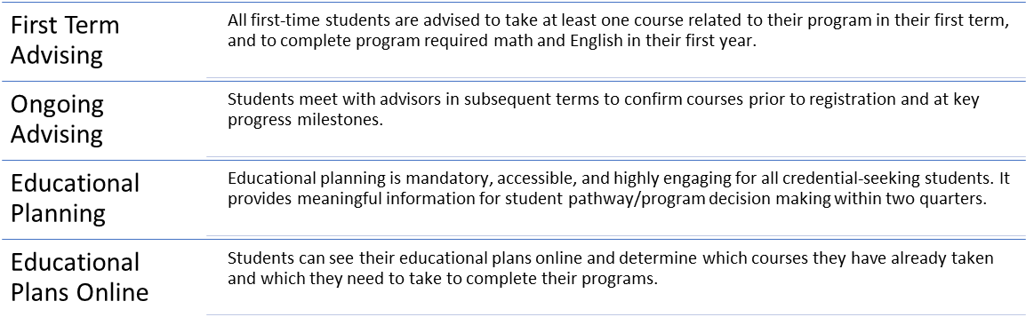

Progress monitoring
The college has policies, practices, and supports in place to work with students to address their barriers, maintain momentum towards completion, and celebrate success.
- Advisors monitor which program every student is in and how far along the student is toward completing the program requirements.
- Advisors and students are alerted when students are at risk of falling off their program plans and have policies and supports in place to intervene in ways that help students get back on track.
- Assistance is provided to students who are unlikely to be accepted into limited-access programs, which redirects them to another more viable path to credentials and a career.
- Student progress monitoring data is used to provide frequent and regular feedback and resources to students, faculty, staff, and administrators.

Section 3: Teaching and Learning
Students’ primary engagement with the college is through their classes and interactions with faculty. It is necessary to ensure that all students have access to high-quality instruction from supported faculty. Guided Pathways minimum implementation includes a student success and support infrastructure built on a foundation that prioritizes equity, inclusion, and the delivery of evidence-based practices in teaching and learning.

Enriched instruction in program foundation courses
Faculty engage in division- or college-wide efforts to improve instruction in program-related foundation courses (beyond math, English, or first-year experience courses).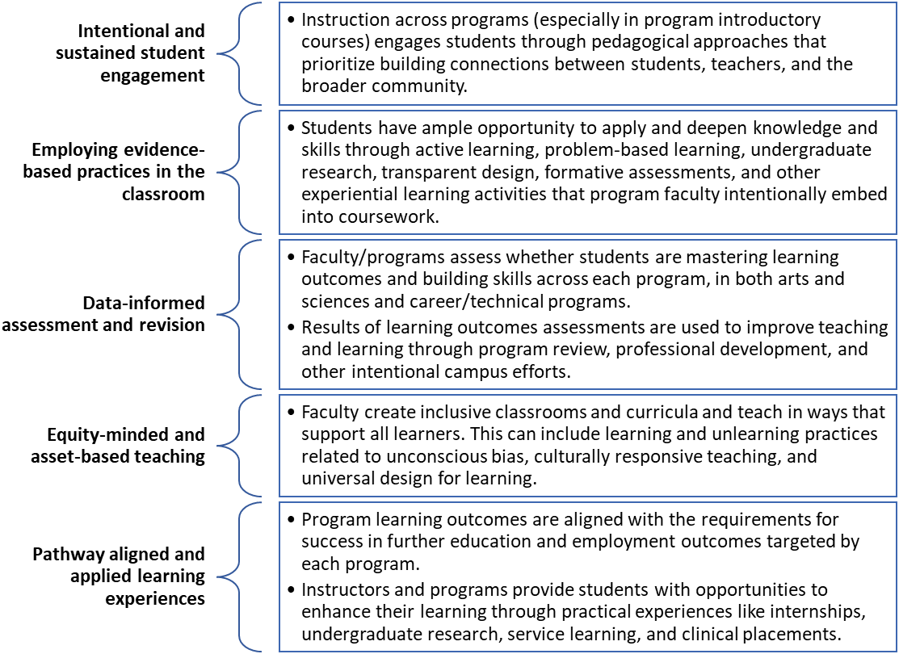

Corequisites and aligned academic support
Students receive the needed academic support in math and English to enroll directly in college-level courses alongside their program required classes. Students get up to speed while working toward their goals, saving money and time that would have been spent on precollege coursework.
Academic support is provided to students in corequisite courses that aligns with the content of their college-level course.



CC BY 4.0, unless otherwise noted.
Washington State Board for Community and Technical Colleges

