# Session Titles, Descriptions, and Outcomes

1. **Basics of Data Entry in LACES**

In this session, we will focus on entering data into LACES. Attendees will learn about reporting changes in LACES and how they impact NRS data collection, reporting, and other systems. This session is most appropriate for new data entry staff and new staff in a leadership position.

1. **Searches, Reports, and Dashboards for Managing Programs** *(repeated)*

In this session, we will focus on the various reporting features throughout LACES that enable users to pinpoint data quality and performance issues within their program or area of responsibility. Attendees will learn about filters and searches as well as static and dynamic reports. This session is most appropriate for data entry staff and program leaders.

1. **Teachers Guide to LACES**

In this session, we will focus on ways instructors can enter attendance, send messages to students, and run reports for students in their classes. Attendees will learn about the limitations and privileges of the Teacher III role in LACES. This session is most appropriate for instructors.

1. **Searches, Reports, and Dashboards for Managing Programs** *(repeated)*

In this session, we will focus on the various reporting features throughout LACES that enable users to pinpoint data quality and performance issues within their program or area of responsibility. Attendees will learn about filters and searches as well as static and dynamic reports. This session is most appropriate for data entry staff and program leaders.

1. **LACES Beyond the Basics: Using Non-Required Fields for Data Entry**

In this session, we will review the non-mandatory fields and options in LACES that are no required for state or federal reporting purposes, but that program staff may find beneficial for getting a holistic picture of the student to provide better tracking and progress. This session is most appropriate for data entry staff and program leaders.

# Presenter Bios

Christy Lowder

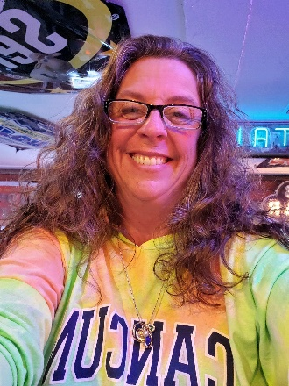

Hello, I am Christy Lowder, Program Specialist III.  I joined the Washington State Board for Community and Technical Colleges in 2003.

My job duties include:

* GED® Support
* I-BEST program application review and maintain the I-BEST website
* BEdA Staff conference/registration/ctcLink support
* BEdA Training Support Coordinator
* BEdA/Corrections website maintenance
* BEdA/Corrections Annual Conferences

Contact me by phone at 360-704-4331 or email me at [clowder@sbctc.edu](mailto:clowder@sbctc.edu).

Scott Toscano



Hello! I am Scott Toscano. I am a Program Administrator at the State Board for Community & Technical Colleges (SBCTC) and my main areas of responsibility include:

* National Reporting System (NRS) Data Collection and Data Quality training.
* State Assessment Policy and CASAS training.
* Responding to internal and external data requests.
* BEdA Reporting systems: WABERS+ programming & LACES vendor coordination.

I started at SBCTC in 2013. Previous experience includes managing a Barnes & Noble College Bookstore, serving as a development and fundraising specialist and serving as a Peace Corps Volunteer. Also, as a teen, I served as a Peer Educator at a runaway shelter, worked at a YMCA daycare, and volunteered as a residential camp counselor for an intensive social justice leadership program for high schoolers called [Anytown](https://www.communitytampabay.org/anytown).

I have a bachelor’s degree from the University of Central Florida and a master’s degree from the School for International Training (SIT). Fun fact, SIT is the institution that first trained Peace Corps Volunteers back in the 60’s. Another little fun string of facts: I am from Florida. I met my wife in Vermont. She is from San Diego, CA. We moved to Washington. So, we’ve covered the four corners of the US together. I live in Olympia and work at SBCTC. I really enjoy working here and supporting BEdA program staff across the system.

My position here at the State Board for Community and Technical Colleges (SBCTC) is Program Administrator and I work in the Basic Education for Adults (BEdA) unit. In this position I provide strategic planning for BEdA program compliance, facilitate all required training, process data requests, and report state-level data to our federal partners. I also coordinate our reporting system’s programming and develop system resources.

-*Scott Toscano, BEdA Program Administrator*

Shannon Stangis

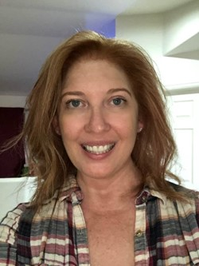

Shannon Stangis is the Director of Client Services and Training Manager for LiteracyPro Systems, Inc., a division of Genius Learning. Her undergraduate background is in Psychology and her graduate education is in Organizational Psychology with an emphasis on adult learning theory related to technology. She has worked with adult education clients providing workforce training and technical support as well as GED preparatory instruction at Workforce Boulder County before coming to work with LiteracyPro Systems and has been the training manager at LiteracyPro for 18 years, providing training for thousands of literacy and adult education clients.