# **Accessing Bridge Modules in Canvas Commons**

**Overview:**

The Bridge Modules have been posted on Canvas Commons in two ways - a course containing all modules and by individual module. This was done to assist those wishing to utilize these modules to access them in whichever format they choose. The directions that follow are for a module by module import from Canvas Commons. All instructions should be followed as written for a successful import of content.

**Bridge Module Import Steps:**

1. Log into Canvas.

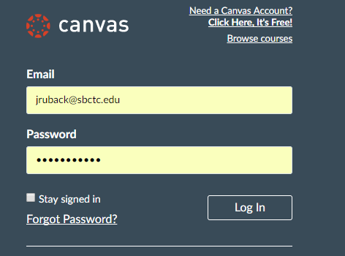

1. Click on **Start a New Course** to create a New Course if your institution allows you to do so.
   1. Name the Course.
   2. Set the Content License to CC Attribution.
   3. Click Create Course.

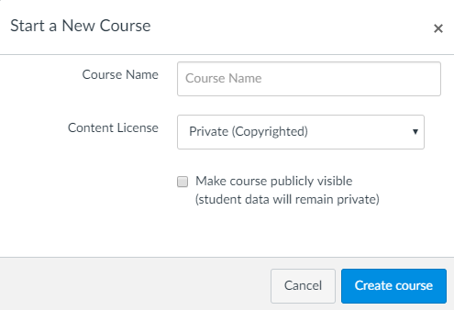

If you do not have permission to create courses, you will need to contact your eLearning Office to have one created for you.

1. When the course opens, click on the **Canvas Commons Logo** on the left side of your screen.

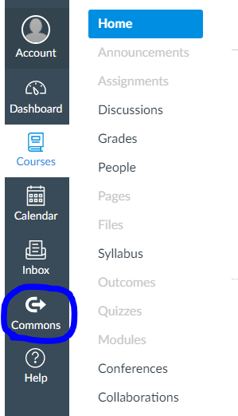

1. Choose one of the following options to begin your search:
   1. Search Ruback (easiest option)
   2. Search by the name of the Bridge Module you are looking for.
   3. Search BEdA Bridge Modules to locate the course with all modules. ***Note: Use this option only if you wish to import all modules within one course.***

Note: Your search will begin as soon as you start typing.

1. When you locate **the course or module, depending on which option you are choosing**, click on the blue hyperlink. Note: You may need to scroll to locate what you are looking for.

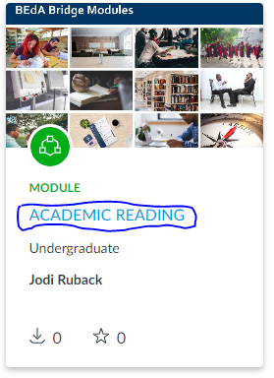

1. You will see a gray **Import into Canvas** box on the right of your screen.
2. Scroll through the list of courses to find your course, and click on the box next to your course name.
3. Then click the green **Import into Course** button. You will see a green box at the top of your screen that tells you you have successfully started your import.

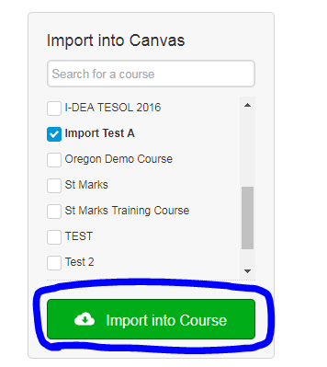

Screen shot of successful import message.

1. Next, return to your **Dashboard**, and open your class.
   1. If you imported the course, in dark gray you will see the:
      1. Course Homepage
      2. Syllabus Tab
      3. Grades Tab
      4. Modules Tab
      5. Collaborations Tab
      6. UDOIT Tab
      7. Accessibility Report Tab
      8. Google Drive Tab
      9. Settings Tab
   2. If you imported a single module, you will see all course navigation tabs on the left, and the module will be shown as your home page. It is recommended that you:
      1. Add a homepage to your course
      2. Update navigation in course settings to only show the following navigation:
         1. Course Homepage
         2. Syllabus Tab
         3. Grades Tab
         4. Modules Tab
         5. Collaborations Tab
         6. UDOIT Tab
         7. Accessibility Report Tab
         8. Google Drive Tab
         9. Settings Tab

## **Instructions for Multiple Single Module Imports:**

1. After your first module import, return to your dashboard, and open your course. When you open your course, click on **Assignments**.

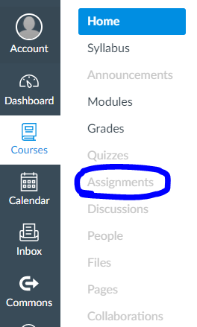

1. You will see two Assignment Groups (Assignments and Imported Assignments).

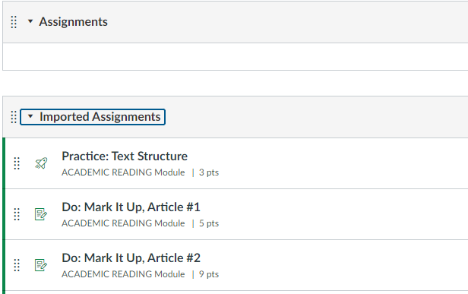

1. Rename the **Imported Assignment** Group to reflect the name of the module.
   1. To do this click on the three ellipses, and click edit.

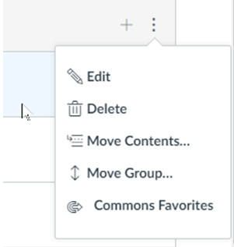

* 1. Type the **Module Name** in the **Group Name** box.
     1. If you are using the **Learner Mastery Model** to assign attendance hours, you will need to set the percent % of the total grade. This will be based on the total number of modules in your Canvas Course. If you don’t know this, you can come back and set the weights later.
  2. Click save.

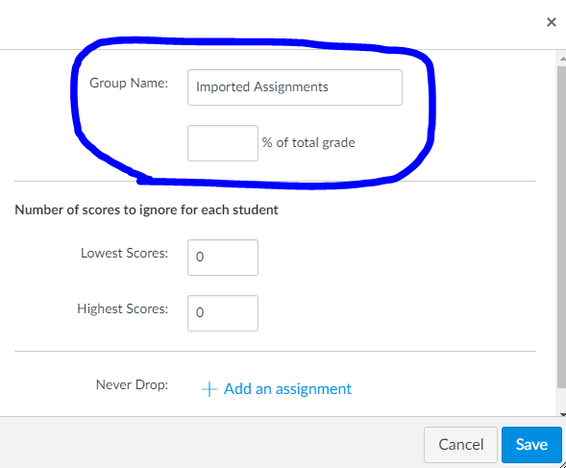

10. Repeat the above steps until you have all content added to your Canvas course.

**Remember, to STOP and rename the Imported Assignment Group after each import from Canvas Commons.**  This will save you from manually having to move module content later.

### **HELPFUL HINT:**

Importing content in the order you will use it will prevent having to rearrange modules later.

## **One Additional Assignment Group-*Learner Mastery Attendance Only*:**

After you have imported all of your course content, you will need to create one additional **Assignment Group** if you are using the Learner Mastery Model to assign attendance hours**.** To do this:

1. Open your course and click on **Assignments.**
2. Click on +Group to Add an Assignment Group.
3. Type Do In Class next to Group Name, and set the weight as 0.
4. Click save.



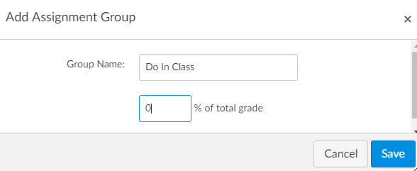

Please don’t forget this step! Doing this will ensure that students do not earn distance education hours for any activities housed in Canvas which are done in class.