**Montana Payroll Taxes**

**MT State Income Tax Withholding**

Montana Employer and Information Agent Guide: <https://mtrevenue.gov/wp-content/uploads/mdocs/withholding_tax_guide.pdf>

Montana Department of Revenue (MDOR) Business & Income Tax Division website: <https://mtrevenue.gov/taxes/>

**Who Must Withhold MT State Income Taxes**

Resident and nonresident employers who pay wages for services performed in Montana are required to withhold Montana income tax. Employers subject to Montana wage withholding requirements must register for a withholding account with the Montana Department of Revenue (MDOR). You may register, remit payments, and file reports electronically through the TransAction Portal (TAP) <https://tap.dor.mt.gov/_/>.

Wage withholding payments are due based on the total amount withheld during the lookback period. The lookback period is the 12-month period from July 1 of the preceding year to June 30 of the current year. For new withholding accounts, payments are due monthly until the initial lookback period is completed.

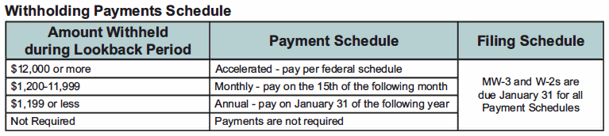

Employers reporting withholding must file a complete Montana Annual W-2 1099 Withholding Tax Reconciliation (Form MW-3) by January 31 of the following year. Employers must include all Forms W-2 for each employee along with Form MW-3, regardless of whether any tax was withheld. You may download a current form from the Montana Department of Revenue Forms Repository at: <https://mtrevenue.gov/forms/>.

**MT W-4 Requirements**

Employees report their number of allowances and/or exemptions on Montana Employee's Withholding Allowance and Exemption Certificate (Form MW-4). You may download a current form from the Montana Department of Revenue Forms Repository at: <https://mtrevenue.gov/forms/>.

**MT State Unemployment Insurance**

In general, workers are covered by the unemployment law of the state in which the work is performed. Employers with employees working in MT may register for a MT unemployment tax account through the UI eServices for Employers portal <https://uieservices.mt.gov/_/>.

A governmental entity may choose from two methods of UI coverage:

* Experience rating system - Governmental entities choosing experience rating pay a 0.09% (.0009) Administrative Fund Tax (AFT) on total wages paid each quarter.
* Reimbursable employer - As a reimbursable employer, you must pay into the UI Trust Fund an amount equal to the benefits charged to your account. You will generally be charged for all benefits paid to former employees regardless of the reason they left your employment. Benefit charges are prorated according to the percentage of wages you paid to the total wages in the claimant’s base period.

As a covered employer for Unemployment Insurance, you must keep payroll records, file UI quarterly wage reports and make timely payment of UI contributions. Employers with 20 or more employees reported in any quarter of the prior year are required to file quarterly UI reports electronically.

UI eServices for Employers users must log in using the ePass Montana portal. Those who do not have an ePass Montana account will need to create one. After entering the ePass Montana account information, the user will be redirected to eServices. A first-time set up will be required when logging into eServices to establish a web profile. Subsequent logins will require entering an ePass Montana user name and password AND an eServices secret answer (second password).

Quarterly wage reports are due on the following dates:

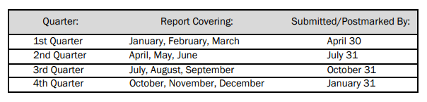

If the due date is on a weekend or holiday, the next business day becomes the date the quarterly reports and payment must be submitted.

MT has adopted the Interstate Reciprocal Coverage Arrangement for unemployment insurance. Under this arrangement, if an employee works in more than one state, an employer may elect to cover all the services of such a worker in any state in which: (1) any part of the worker's service is performed, (2) the worker has his or her residence, or (3) the employer maintains a place of business. To elect reciprocal coverage, contact Montana Unemployment Insurance Division for assistance: (406) 444-3834.

**MT State Workers’ Compensation**

Workers’ Compensation insurance is mandatory in Montana. MT provides three different insurance plans for workers' compensation: (1) self-insurance; (2) private insurance; and (3) state fund.

Washington State Department of Enterprise Services (DES) administers a Workers' Compensation Insurance program for state workers. If your employee works outside of Washington in a single other state for more than 30 days (240 hours) per year, **your agency must work with DES** to insure your out-of-state employee. For more information, contact Kimberly Haggard [kimberly.haggard@des.wa.gov](mailto:kimberly.haggard@des.wa.gov) at DES Risk Management.

**MT State Paid Family / Medical Leave**

Montana does not have a paid family and medical leave program as of 02/21/2024.

**Helpful resources for Montana**

MT Department of Labor & Industry Unemployment Insurance Division website: <https://uid.dli.mt.gov/>

MT Department of Labor & Industry Unemployment Insurance Division Employer Resources website: <https://uid.dli.mt.gov/employers/>

MT DOL Unemployment Insurance Division Employer Handbook: <https://uid.dli.mt.gov/employer-handbook.pdf>

MT UI Reimbursable Employers information: <https://uid.dli.mt.gov/employers/reimbursable-employers>

MT UI Governmental Entities information: <https://uid.dli.mt.gov/employers/governmental-entities>

MT Department of Labor & Industry Workers’ Compensation website: <https://erd.dli.mt.gov/>