**Michigan Payroll Taxes**

**MI State Income Tax Withholding**

Michigan Department of Treasury Withholding Tax Website: <https://www.michigan.gov/taxes/business-taxes/withholding>

**Who Must Withhold MI State Income Taxes**

Every Michigan employer required to withhold federal income tax under the Internal Revenue Code must be registered for and withhold Michigan income tax. Employers located outside Michigan that have employees who work in Michigan must register and withhold Michigan income tax from all employees working in Michigan. Register with the Michigan Department of Treasury (Treasury) via the Michigan Treasury Online (MTO) web service by following this link: <https://mto.treasury.michigan.gov/eai/mtologin/authenticate?URL=/>. Step-by-step guides are available on the MTO Tutorials website: <https://www.michigan.gov/taxes/business-taxes/mto/help>.

All taxpayers must file return(s) and remit applicable payment(s) according to their filing frequency established by Treasury. Initially, Treasury determines your filing frequency based on your estimated monthly payment for each tax that you registered for on your registration application. Subsequently, your filing frequency is reviewed by Treasury annually for update. If your filing frequency is changed, you will be notified in writing.

Filing Deadlines

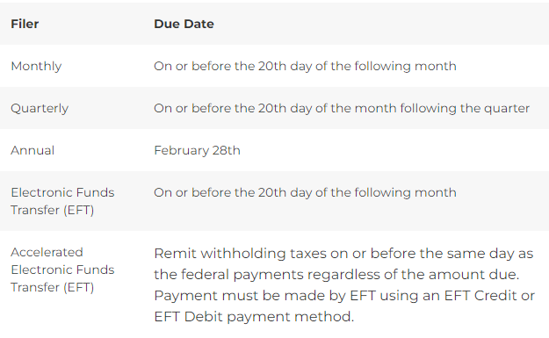

Treasury requires issuers of Forms W-2 to file state copies of W-2s (income record forms) when issued to a Michigan resident employee, to report work performed in Michigan, or to report Michigan income tax withheld. Income record forms are due to Treasury on or before January 31 of the following year. The Income Record Form Remittance Guide <https://www.michigan.gov/taxes/business-taxes/incomestatement/income-record-form-remittance-guide> provides an overview and current filing options.

**MI Local Income Taxes**

Some cities in Michigan impose local income taxes. If your Michigan employee is working remotely from Albion, Battle Creek, Benton Harbor, Big Rapids, Detroit, East Lansing, Flint, Grand Rapids, Grayling, Hamtramck, Highland Park, Hudson, Ionia, Jackson, Lansing, Lapeer, Muskegon, Muskegon Heights, Pontiac, Port Huron, Portland, Saginaw, Springfield, or Walker you'll need to register, withhold, remit, and report those local income taxes. More information is available on the MI Taxes FAQ website: <https://www.michigan.gov/taxes/questions/iit/epay/general/what-cities-impose-an-income-tax>.

**MI W-4 Requirements**

Every employer must obtain a *Withholding Exemption Certificate* (Form MI-W4) from each employee. The federal W-4 cannot be used in place of the MI-W4. A current Form MI-W4 may be downloaded from this website: <https://www.michigan.gov/taxes/business-taxes/withholding/calendar-year-tax-information>.

**MI State Unemployment Insurance**

In general, workers are covered by the unemployment law of the state in which the work is performed. The Michigan Unemployment Insurance Agency (UIA) administers the unemployment insurance program that provides temporary financial assistance to individuals who become unemployed through no fault of their own. Benefits are paid through taxes on employers covered under the Michigan Employment Security Act. Employers may register for a Michigan Unemployment Insurance account via the department’s MiWAM Employer Registration website by following this link: <https://miwam.unemployment.state.mi.us/mip/ereg/_/>

For Michigan unemployment purposes, a governmental unit is automatically a reimbursing employer, unless it requests, in writing, to be a contributing employer. A reimbursing employer does not pay quarterly taxes to the UIA. But if unemployment benefits are paid to former employees, the reimbursing employer must repay UIA, dollar-for-dollar, for unemployment benefits paid out.

Michigan unemployment tax and wage reports and tax payments are due quarterly on the following dates:

APRIL 25 | JULY 25 | OCTOBER 25 | JANUARY 25

Important notes about filing quarterly reports:

1. You must file an Employer’s Quarterly Wage/Tax Report every quarter, even if you are unable to pay or have no payroll for the quarter.

2. If you do not submit your reports and payments accurately and on time, penalty and interest will be applied to your account.

3. You can sign up for email reminders through MiWAM so you never miss a date.

MI has adopted the Interstate Reciprocal Coverage Arrangement for unemployment insurance. Under this arrangement, if an employee works in more than one state, an employer may elect to cover all the services of such a worker in any state in which: (1) any part of the worker's service is performed, (2) the worker has his or her residence, or (3) the employer maintains a place of business. The agreement should be initiated through the state where the employer wants to report the payroll. A Washington employer may request to elect reciprocal coverage with another state by following the filing process outlined by Washington Administrative Code 192-300-150: <https://app.leg.wa.gov/wac/default.aspx?cite=192-300-150>.

**MI State Workers’ Compensation**

Nearly all employers in Michigan are subject to the Workers' Disability Compensation Act. The law requires that every covered employer must provide some way of assuring that benefits are paid to its workers if they become injured while on the job. Most employers do this by purchasing an insurance policy from a private insurance company. However, some employers are granted self-insured status, and others join a group fund. For more information on insurance coverage requirements and exclusions, call the [Insurance Compliance Division](https://www.michigan.gov/leo/bureaus-agencies/wdca/insurance-requirements) at 517-284-8922.

Washington State Department of Enterprise Services (DES) administers a [Workers' Compensation Insurance program](https://des.wa.gov/sites/default/files/2023-08/Out-Of-State-Workers-Compensation-FAQs.pdf) for state workers. If your employee works outside of Washington in a single other state for more than 30 days (240 hours) per year, **your agency must work with DES** to insure your out-of-state employee. For more information, contact Kimberly Haggard [kimberly.haggard@des.wa.gov](mailto:kimberly.haggard@des.wa.gov) at DES Risk Management.

**MI State Paid Family / Medical Leave**

Michigan does not have a paid family and medical leave program as of 10/18/2024.

Washington Paid Family & Medical Leave (PFML) and Washington Cares benefits are not available to employees who are physically working in Michigan. If agencies have WA PFML or WA Cares policy questions they are asked to email Washington Employment Security Department at [esddlpfmlpolicy@esd.wa.gov](mailto:esddlpfmlpolicy@esd.wa.gov).

**Helpful resources for Michigan**

Withholding tax contact information:

Michigan Department of Treasury

PO Box 30427

Lansing, MI 48909

Telephone: 517-636-6925

Michigan Unemployment Insurance Agency (UIA) website: <https://www.michigan.gov/leo/bureaus-agencies/uia>

Michigan Labor and Economic Opportunity (LEO) Unemployment Insurance Employer Help Center website: <https://www.michigan.gov/leo/bureaus-agencies/uia/tools/employer-help-center>

Michigan Workers’ Disability Compensation Agency Employers and Business Owners website: <https://www.michigan.gov/leo/bureaus-agencies/wdca/employers-and-business-owners>

For ctcLink vendor setup, the MI employer withholding tax mailing address is:

Michigan Department of Treasury

PO Box 30406

Lansing, MI 48909-7906

Vouchers should be made payable to “State of Michigan”.

For ctcLink vendor setup, the MI unemployment insurance tax mailing address is:

Unemployment Insurance Agency

PO Box 33598

Detroit, MI 48232-5598

Vouchers should be made payable to “Unemployment Insurance Agency”.