**Kansas Payroll Taxes**

**KS State Income Tax Withholding**

Link to Kansas Department of Revenue withholding website: <https://www.ksrevenue.gov/bustaxtypeswh.html>.

Link to Kansas Withholding Tax Guide: <https://www.ksrevenue.gov/pdf/kw100.pdf>

**Who Must Withhold KS State Income Taxes**

Kansas has a state income tax on personal income. An employer must withhold Kansas tax if the employee is a resident of Kansas performing services inside or outside of Kansas, or a nonresident of Kansas performing services in Kansas.

How often you will file and pay Kansas withholding tax depends on the size of your payroll. The larger your payroll, the larger the Kansas withholding, and therefore the more frequently you will report and pay the tax. Kansas has five filing frequencies — annual, quarterly, monthly, semi-monthly, and quad-monthly. Your initial filing frequency is based on the estimated tax amount you enter in Part 6 of the business tax application. Your filing frequency will be shown on your Withholding Registration Certificate.

Each filing frequency has a different set of due dates (see chart below). Do not file your Kansas withholding tax either more or less frequently than your established filing frequency.

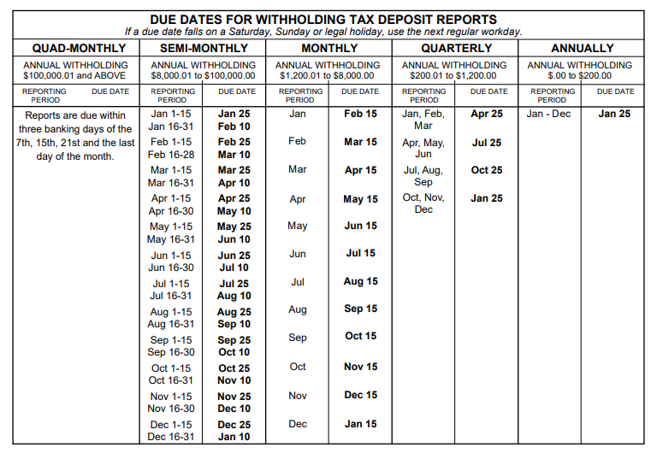

Employers must give each employee three copies of the Wage and Tax Statement, form W-2, by January 31 of the following year, even if no Kansas tax was withheld. Once completed, a copy of the W-2 form must be submitted to the Kansas Department of Revenue (KDOR). Employers submitting more than 50 W-2 records must file electronically. Employers reporting less than 51 records can file on paper but are encouraged to use the online application to submit their W-2s. A Kansas KW-3 Annual Withholding Tax Return must be filed electronically along with the W-2s.

The Kansas Department of Revenue’s (KDOR) Customer Service Center web portal (<https://www.kdor.ks.gov/Apps/kcsc/login.aspx>) allows you to register with the KDOR to withhold Kansas income tax from wages and other taxable payments subject to Kansas withholding tax. After registering and creating an account, you will be able to make electronic payments, file your withholding returns, and view your online activity. Employers are required to submit withholding tax returns electronically.

**KS W-4 Requirements**

Employees with Kansas source wages hired after Dec. 31, 2007 are required to complete and submit Kansas Form K-4 to their employer on or before the date of employment. Follow this link to view and download KS Employees Withholding Allowance Certificate (K-4) Form and Information: <https://www.ksrevenue.gov/k4info.html>.

**KS State Unemployment Insurance**

In general, workers are covered by the unemployment law of the state in which the work is performed. All employers doing business in Kansas are subject to the provisions of the Employment Security Act. However, not all are subject to the taxing provisions of the law. Coverage is determined by the type and nature of the business, the number of workers employed, and the amount of wages paid for employment.

Every employing unit that begins business operations in Kansas is required to register for an unemployment insurance account with the Kansas Department of Labor (KDOL) within 15 days of hiring its first employee. An employer may file form [K-CNS 010](https://www.dol.ks.gov/home/showpublisheddocument/24/638363146925370000), Status Report, or register via the KDOL’s Wage & Tax Reporting System at: <https://kansaslabor.gov/accessks/faces/login/login_local.xhtml>. Upon registration, a determination of employer liability will be made by the agency and the employer notified.

You are automatically liable for coverage if you are a state or local governmental organization, an instrument of a state or local government, or an Indian tribe. If you meet liability requirements at any time during a year, you must file a Quarterly Wage Report and Unemployment Tax Return for all quarters of that year in which you had any employment. A quarterly wage report must be filed each quarter thereafter.

Liable employers under the Kansas Employment Security Law fall into one of three main categories – contributing, reimbursing, or rated governmental – depending upon the method of financing the employer uses to satisfy the unemployment compensation tax liability. While the majority of liable employers in Kansas are required to be “contributing” employers,

provisions of the law specify that nonprofit organizations exempt under 501(c)(3) of the Internal Revenue Code and governmental entities may elect an alternative method to finance their tax liability. One alternative, the reimbursing payment method, is available only to governmental entities, Indian Tribes or nonprofit organizations that are exempt under the Internal Revenue Code, Section 501(a) and specifically described in Section 501(c)(3). Election of the reimbursing payment option must be for a minimum of four complete calendar years; and a surety bond is required.

Please be advised that all Washington State Community and Technical Colleges have selected the Reimbursable method for Washington unemployment insurance. Whenever possible, it is recommended as a best practice for colleges to adopt the same approach for their non-Washington state unemployment insurance method.

All liable employers are required to file an Employer’s Quarterly Wage Report ([K-CNS 100](https://www.dol.ks.gov/home/showpublisheddocument/20/638363146920370000)) for any quarter they are liable, reporting any wages paid to their workers, both permanent and temporary. The department encourages all employers to file their reports electronically. Quarterly filings and payments can be made easily and securely on the KDOL website: <https://www.kansasemployer.gov/uitax/account/Login.aspx>. After you have completed the online registration form you can enter your wage data directly into a secure form. You also may upload wage data files.

KS has adopted the Interstate Reciprocal Coverage Arrangement for unemployment insurance. Under this arrangement, if an employee works in more than one state, an employer may elect to cover all the services of such a worker in any state in which: (1) any part of the worker's service is performed, (2) the worker has his or her residence, or (3) the employer maintains a place of business. The agreement should be initiated through the state where the employer wants to report the payroll. A Washington employer may request to elect reciprocal coverage with another state by following the filing process outlined by Washington Administrative Code 192-300-150: <https://app.leg.wa.gov/wac/default.aspx?cite=192-300-150>.

**KS State Workers’ Compensation**

The Kansas Department of Labor Workers’ Compensation Division is responsible for the administration of the Kansas Workers’ Compensation laws and rules. Generally, an employer in a non-agricultural business with more than $20,000 in payroll must secure workers’ compensation benefits for its employees.

Washington State Department of Enterprise Services (DES) administers a [Workers' Compensation Insurance program](https://des.wa.gov/sites/default/files/2023-08/Out-Of-State-Workers-Compensation-FAQs.pdf) for state workers. If your employee works outside of Washington in a single other state for more than 30 days (240 hours) per year, **your agency must work with DES** to insure your out-of-state employee. For more information, contact

Kimberly Haggard [kimberly.haggard@des.wa.gov](mailto:kimberly.haggard@des.wa.gov) at DES Risk Management.

**KS State Paid Family / Medical Leave**

Kansas does not have a paid family and medical leave program as of 01/28/2025.

Washington Paid Family & Medical Leave (PFML) and Washington Cares benefits are not available to employees who are physically working in Kansas. If agencies have WA PFML or WA Cares policy questions they are asked to email Washington Employment Security Department at [esddlpfmlpolicy@esd.wa.gov](mailto:esddlpfmlpolicy@esd.wa.gov).

**Helpful resources for Kansas**

KDOR Withholding Tax Forms and Publications: <https://www.ksrevenue.gov/forms-btwh.html>

KS Unemployment Tax website for Employers: <https://www.dol.ks.gov/employers/employer-services/unemployment-tax>

KS Unemployment Insurance Employer Handbook: <https://www.dol.ks.gov/home/showpublisheddocument/68/638458465075100000>

KS Workers Compensation Division website: <https://www.dol.ks.gov/workers-compensation/overview>

The ctcLink vendor for KS employer withholding tax is 0000064097

Kansas Withholding Tax

Kansas Department of Revenue

PO Box 3506

Topeka, KS 66625-3506

The ctcLink vendor for KS unemployment insurance tax is 0000064098

Kansas Employment Security Fund

Kansas Department of Labor

PO Box 400

Topeka, KS 66601-0400