**Colorado Payroll Taxes**

**CO State Income Tax Withholding**

You may review or download the Colorado Wage Withholding Tax Guide from the Colorado Department of Revenue Taxation Division website: <https://tax.colorado.gov/withholding-tax-guide>.

**Who Must Withhold CO State Income Taxes**

Every employer making payment of wages or other compensation to employees for services performed within Colorado State is required to apply for and maintain an active Colorado Wage Withholding account. Apply for an account online via the Colorado Business Express website: <https://mybiz.colorado.gov/intro>, or by preparing and submitting a paper form CR 0100, *Colorado Sales Tax and Withholding Account Application*, available online from the Colorado Department of Revenue (CDOR) website: <https://tax.colorado.gov/withholding-forms>. Follow the application instructions to submit your completed application.

*\*Note:* Out-of-state employers, regardless of business classification, are not required to register with the Colorado Secretary of State, as long as the business is registered in another state.

An employer who is required to withhold Colorado income tax from employees’ wages is liable for the required withholding, whether or not the employer actually withholds the tax. Form DR 1098, *Colorado Withholding Worksheet for Employers*, available online at: <https://tax.colorado.gov/DR1098>, prescribes the method for calculating the required amount of withholding.

The amount of Colorado withholding tax taken out of the wages paid by a company to its employees determines how often the company must file withholding returns and pay the tax due.

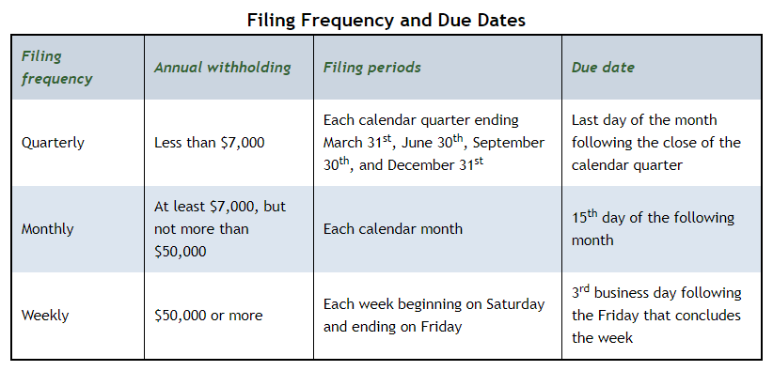

Employers may file returns electronically at Colorado Revenue Online: <https://www.colorado.gov/revenueonline/_/>.

Every employer must prepare a W-2 for each employee to report the Colorado income taxes withheld from each employee’s pay. The employer must provide copies of the W-2 both to the employee and to the CDOR no later than January 31st of the following year.

**CO W-4 Requirements**

In addition to IRS Form W-4, Colorado employees may elect to complete Form DR 0004, *Colorado Employee Withholding Certificate,* to adjust Colorado wage withholding. The form and instructions are available online from the CDOR website at: <https://tax.colorado.gov/DR0004>.

**CO State Unemployment Insurance**

In general, workers are covered by the unemployment law of the state in which the work is performed. Nonprofit, Reimbursable, and Government Employers should complete and submit Form UITL-100, *Application for Unemployment Insurance Account and Determination of Employer Liability*, available for download from the Colorado Department of Labor and Employment (CDLE) Forms & Publications website: <https://cdle.colorado.gov/employers/forms-publications>.

A newly subject nonprofit employer may elect the reimbursement method of payment (the agency is billed for its share of unemployment benefits paid to former employees) within 30 days of determination of liability.

Colorado employers should use the MyUI Employer+ system to file wage reports and pay premiums. To register, go to <https://cdle.colorado.gov/employers/myui-employer-plus>. Step-by-step “How to Register” instructions are available online at: <https://cdle.colorado.gov/employers/myui-employer/resources/how-to-register-a-new-ui-employer-account-in-myui-employer>.

Wages subject to unemployment are called “covered employment” and are reported on a quarterly basis. The quarterly reports and premiums owed for the quarter are due on the last day of the month following the end of the calendar quarter (example: first quarter ends March 31, so first quarter reports are due by April 30). Employers are responsible for filing premium reports and wage reports.

CO has adopted the Interstate Reciprocal Coverage Arrangement for unemployment insurance. Under this arrangement, if an employee works in more than one state, an employer may elect to cover all the services of such a worker in any state in which: (1) any part of the worker's service is performed, (2) the worker has his or her residence, or (3) the employer maintains a place of business. However, the policy in Colorado is that employers do not elect the state to which they report wages but may submit a request to the UI tax section for coverage in another state. The tax section will render a decision on the request according to state law, and a written decision will be issued to the employer.

**CO State Workers’ Compensation**

All public and private employers in Colorado, with limited exceptions, must provide workers’ compensation coverage for their employees if one or more full- or part-time persons are employed. Workers’ compensation insurance coverage is paid by the employer. Employers purchase insurance coverage through a commercial insurance carrier or, if qualified, through self-insurance programs. No portion of the premium may be deducted from an employee’s wages.

Washington State Department of Enterprise Services (DES) administers a Workers' Compensation Insurance program for state workers. If your employee works outside of Washington in a single other state for more than 30 days (240 hours) per year, **your agency must work with DES** to insure your out-of-state employee. For more information, contact Kimberly Haggard [kimberly.haggard@des.wa.gov](mailto:kimberly.haggard@des.wa.gov) at DES Risk Management.

**CO State Paid Family / Medical Leave**

If your business has at least one employee, you must register with the state-run Paid Family

and Medical Leave Insurance (FAMLI) Division and are required to follow all its rules and regulations in order to remain compliant with Colorado’s Family and Medical Leave Insurance Act. FAMLI is funded by both employers and employees. Employers are responsible for collecting the employee’s contribution of the premium through payroll deductions and sending the full amount to the Division once a quarter.

Your total nationwide employee count will be what determines whether or not you pay the employer share of the premium. You will only need to pay premiums for the employees who are localized in Colorado. For example, if you have 15 employees nationwide, and 8 working completely in Colorado, you as the employer would be required to pay the employer's share and collect and remit the employee's share for each of those 8 employees.

My FAMLI+ Employer is the online employer services portal Colorado businesses use to register and manage their employer responsibilities under FAMLI. My FAMLI+ Employer operates similarly to My UI Employer, allowing employers to report wage data, remit premium payments, apply for private plan approval, and upload letters of declination votes. Colorado businesses need to register for a My FAMLI+ Employer account at: <https://famli.colorado.gov/>.

Washington Paid Family & Medical Leave (PFML) and Washington Cares benefits are not available to employees who are physically working in Colorado. If agencies have WA PFML or WA Cares policy questions they are asked to email Washington Employment Security Department at [esddlpfmlpolicy@esd.wa.gov](mailto:esddlpfmlpolicy@esd.wa.gov).

**CO Local Taxes**

In addition to state withholding tax, five cities or municipalities in Colorado also have an Occupational Privilege Tax (OPT). The taxes are levied based on the city where work is performed. Each city sets an income threshold to determine which employees are subject to the tax. The threshold is the minimum amount an employee must earn per month in the city. Once the employee reaches the minimum amount of pay, the employee and employer are subject to the OPT for the month.

OPT is paid at a flat rate. This means you withhold and contribute a set dollar amount instead of paying a percentage of employee wages. Some Colorado cities and municipalities exempt Government employers from the employer portion of OPT taxes.

Employers are responsible to register, withhold employees’ tax from wages, report, and remit taxes to applicable cities or municipalities. Contact each city or municipality to determine OPT liability and register for an account.

Aurora <https://www.auroragov.org/business_services/taxes/occupational_privilege_tax>

Denver <https://www.denvergov.org/Government/Agencies-Departments-Offices/Agencies-Departments-Offices-Directory/Department-of-Finance/Our-Divisions/Treasury/Business-Tax-Information>

Glendale <https://www.glendale.co.us/355/Occupational-Privilege-Tax>

Greenwood <https://www.greenwoodvillage.com/1220/Occupational-Privilege-Tax-OPT>

Sheridan <https://www.ci.sheridan.co.us/288/Occupational-Privilege-Tax>

**Helpful resources for Colorado**

A free CO Wage Withholding Webinar is available on the Colorado Department of Revenue’s (CDOR) website: <https://tax.colorado.gov/wage-withholding-webinar>

Colorado Department of Labor and Employment (Unemployment) Employers website: <https://cdle.colorado.gov/employers>

CDLE (Unemployment) MyUI Employer Resources website: <https://cdle.colorado.gov/employers/myui-employer/resources>

CDLE (Unemployment) Employer Handbook: <https://cdle.colorado.gov/sites/cdle/files/Employer_Guide_0.pdf>

CDLE (Unemployment) Forms & Publications website: <https://cdle.colorado.gov/employers/forms-publications>

View CO Family and Medical Leave Insurance Program (FAMLI) Employer FAQs at: <https://famli.colorado.gov/employers/employer-faqs>

My FAMLI+ Employer User Guides and How-To Videos are available at: <https://famli.colorado.gov/employers/my-famli-employer>