**OFM I-038 Interface File/OFM CIMA access:**

The OFM Interface file (I-038) HR Data is run by the ERP Technical Production Analyst after each payroll has been confirmed. This file goes to OFM where they load the data into their system and then, if there are no issues with the load, they produce reports for the colleges to review. The reports will tell the colleges if all of the data received from the I-038 was acceptable (PASSED), or if there are errors that need to be addressed so the file can be ran again and resent. This is done until there are no more errors when OFM loads the data to their system.

After the I-038 has been sent to OFM and they load the data and produce the reports (usually the next day after receiving the I-038 file), ERP HCM Support analyst should review the as well to see if there are errors. If there are errors, provide assistance to the colleges if needed to fix the issues that are causing the reports.

To access the OFM Compensation Impact Model Agency Interface (OFM CIMA) to view the reports, you need to have a user name and password. You can obtain this from Pam Johnson from OFM.

Link to the OFM CIMA site: <https://fortress.wa.gov/ofm/cimai/heMenu.aspx>

Each college has a unique “Agency” number. You should have your own login for each college. If not you have to search through the reports to find the one you need ie: Spokane 676, Tacoma 678.

Example of Spokane 676 Transmittal status Reports page:

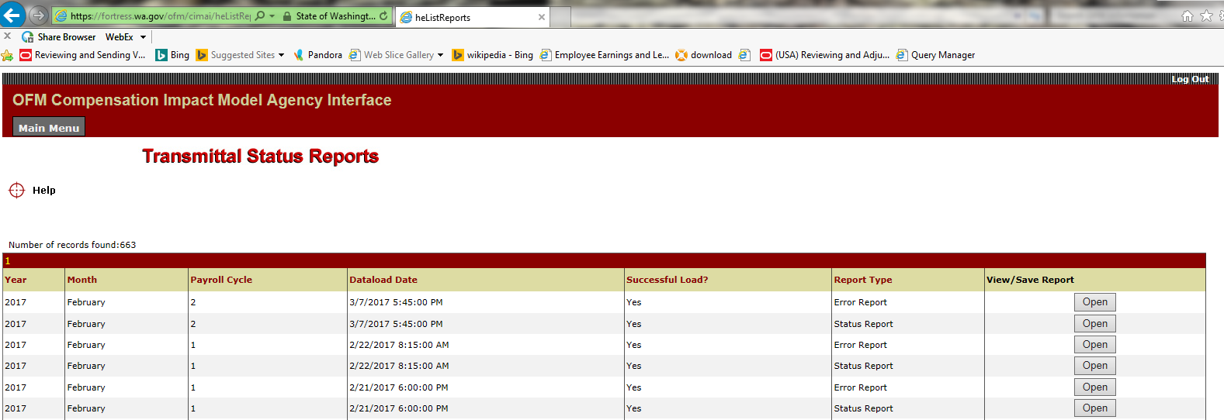

Example of error messages on report.

This example is a Warning only, no action is required for this agency to pass the OFM file load.

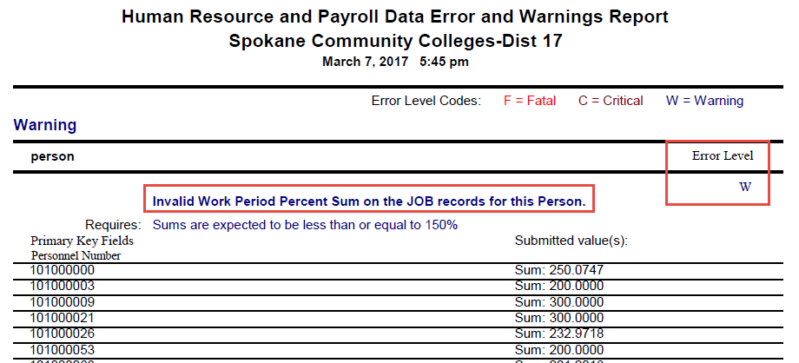

Below are some typical Fatal and Critical errors and their possible solutions:

**IMPORTANT:** All **FATAL** and **CRITICAL** errors must be corrected ASAP and the I-038 process ran again so a new file can be sent to OFM that day. It is very important to make sure the colleges resolve these errors the same day they receive the notification from OFM.

**OFM-HR/Payroll Data Error and Warnings Report Solutions:**

**FATAL ERRORS**

**Error Message:** (Person) Data Field: Agency Code, New Social Security Number Duplicate Records. Requires: A single person record per employee.

**Definition:** More than one Empl ID has the same SSN.

**Solution:** Update the National ID field with correct SSN for each employee.

**Navigation:** Main Menu>Workforce Administration>Personal Information>Biographical>Modify a Person.

**Error Message:** (Job) Appointment Start Date, invalid Field Value. Requires: Valid date between current date less 65 years and three months in the future.

**Definition:** The effective date on the job data record is too old. There are several job records that have an effective date of 01/01/1901.

**Solution:**  Add a row to the Job Data record/Job Information tab, using the actual start date for the appointment.

**Navigation:** Main Menu>Workforce Administration>Job Information>Job Data>Job Information

**Error Message:** (Job or Payroll Detail) Agency Code, New Social Security Number, Position Number Duplicate Records.

**Definition:** These employees have more than one Empl Record with the same Position number.

Solution: Add a row to the Job Data/Work Location tab to update the Empl Records with the correct Position number.

**Navigation:**  Main Menu>Workforce Administration>Job Information>Job Data/Work Location

**CRITICAL ERRORS**

**Error Message:** (Job) Invalid Pay Scale Group Code/Pay Scale Level Code combination. Requires: When Pay Scale Area is not 40 and Pay Unit is Monthly: PST/PSA/PSG?PSL combo must be in institution Pay Schedule file; When Pay Scale Area is 40: PSG/PSL must be 99999999 and 99 respectively for monthly employees and PSG should be HRY for Hourly employees.

**Definition:** The step is blank on the Salary Plan tab of Workforce Administration. The report has Pay Scale Level=99. 99 is a default if Step is unknown.

**Solution:** If an employee has a salary admin plan and grade and no step, on PS job,  but the corresponding plan/grade table has more steps than 1,  then the job needs to have the step field populated.  Plan/grades with only one step are contracts and a step isn’t required on the job. Enter the applicable Step Level.

**Navigation:** Main Menu>Workforce Administration>Job Information>Job Data>Salary Plan

**Error Message:** (Job)Invalid Proration Percent Sum on the Funding records associated with these jobs.

**Definition:** There is more than one active Empl Record with an FTE of 1.0 and an Earnings Distribution of 100%.

**Solution:** Add a row on the Empl Record to change the FTE amount.

**Navigation:** Main Menu>Workforce Administration>Job Information>Job Data>Job Information

**Error Message:** (Job) Zero funding records for these jobs. Requires: At least one fund record per job.

**Definition:** On the CTC Earnings Distribution tab in Workforce Administration, there is either no combo code or if you click on the Edit Chart Fields, there are sections of the chart field missing.

**Solution #1:** If the combo code is missing, select Correct History to add a row and then select Edit Chart Field to select a combo code.

**Navigation:** Main Menu>Workforce Administration>Job Information>Job Data>CTC Earnings Distribution

**Solution #2:** If the combo code is already assigned but there are sections of the chart field missing, contact your Finance Administrator to add the missing fields. The Finance Administrator will then need to have that data sent to HCM. ERP Support (HCM) will receive notification from Finance to run the Bud003 Process to pull the updated chart field information into HCM.

**Error Message:** (Job) Last Increment Date Invalid Field Value.

**Definition:** In the Salary Plan Tab of Workforce Administration, the Step Entry Date is blank.

**Solution:** Add a row to enter a Step Entry Date for this Empl Record.

**Navigation:** Main Menu>Workforce Administration>Job Information>Job Data>Salary Plan