





**Human Capital Management Management Image 36 Overview**

Table of Contents

**Contents**

Contents

Introduction 3

Payroll 3

Hours Field Expansion 3

Updated Federal / State Tax Table 3

Federal Tax Data Update 3

State Auto Tax Default for Oregon 4

Updated TAX910ER - Year End Record Error Report 5

Updated Log File Info to Assist in Troubleshooting 6

ESS Paycheck/Pay Advice PDF 7

ESS W-4 Validation Update 8

ESS W-4 PDF: Updated AZ A-4 9

ESS Idaho W-4 PDF 10

Changes to Paycheck Modeling 11

Paysheet Holding Update 11

Accessibility 12

ePay 12

MSS - Approvals 13

HR Core 14

## Introduction

The Image/Upgrade Overview Document is intended to provide ctcLink users with a summary of the changes that will be made in the system as a result of the upcoming image or PeopleTools upgrade implementation. Oracle releases multiple PeopleSoft updates, called images, for each pillar every year. Each Image contains bug fixes and features that are important for PeopleSoft to work well. PeopleTools upgrades update the underlying framework of the system. There are minimal changes that are noticeable to the end users. Below is an overview of the changes that you can expect to see as part of this upgrade.

## Payroll

### Hours Field Expansion

PeopleSoft Payroll for North America product has been updated to enable the storing of piece work [or “unit of work”] information by increasing the length of the YTD, QTD and MTD fields from 9,999.99 to 999,999.99. Multiple programs and online objects have been updated to enable YTD, QTD and MTD hours and adjustment YTD, QTD and MTD hours to reach a maximum of 999,999.99 hours. The processes that produce wage statements PDFs have been modified to print the expanded YTD and total hour fields on the paycheck and advices.

Prior to the modifications, YTD, QTD and MTD hours and adjustment YTD, QTD and MTD hours could not exceed 9,999.99 hours. The paycheck and advice YTD and Total hours had a maximum limit of 9,999.99 hours.

### Updated Federal / State Tax Table

**ID** - The Federal / State Tax Table is updated with a new row dated 06/16/2020, which includes Idaho withholding tax changes published by the Idaho State Tax Commission, effective June 16, 2020.

[Idaho: Table for Percentage Computation Method of Withholding](https://tax.idaho.gov/pubs/EPB00744_06-16-2020.pdf)

**OR** - The Oregon state minimum wage is increased from $12.50 to $13.25 per hour, effective July 1, 2020.

[Oregon Minimum Wage Increase Schedule](https://www.oregon.gov/boli/workers/Pages/minimum-wage-schedule.aspx)

### Federal Tax Data Update

Federal Tax Data has been updated to issue a validation error message, “Invalid Federal Form W-4 Version Selected.” (2000,1502), in the following scenario:

* A new Federal Tax Data row is inserted with an effective date 01/01/2020 or later; and
* Federal Form W-4 Version = “2019 or Earlier; and
* A change is made to the Federal Tax Data record.

Prior to the modifications, the payroll administrator was allowed to update the employee’s federal tax data record with an invalid setup.

#### Navigation

NavBar > Navigator > Payroll for North America> Employee Pay Data USA > Tax Information

Image: Update Employee Tax Data

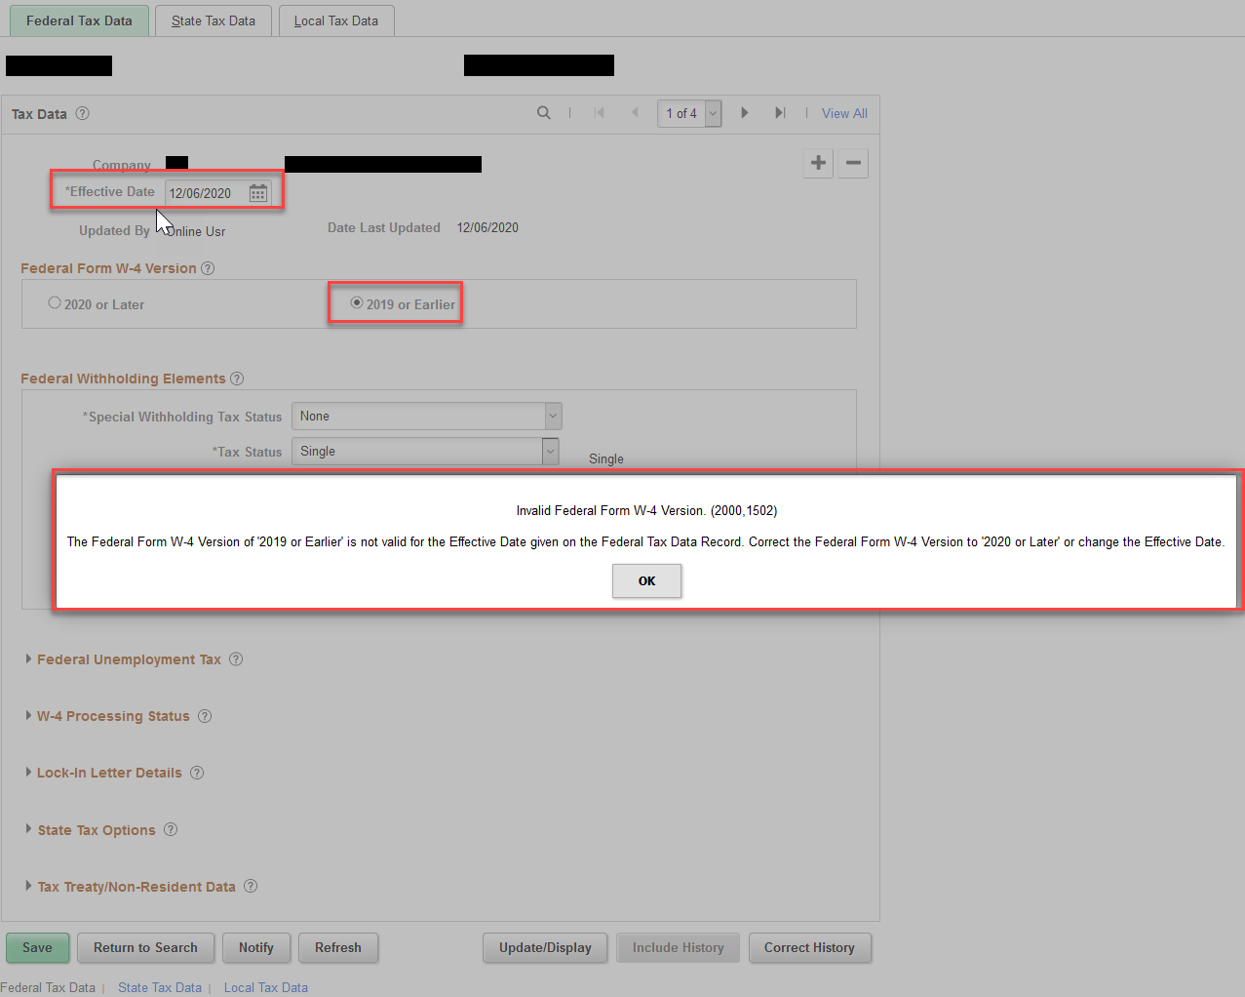

#### QRG

[9.2 Entering U.S. Employee Tax Data](http://ctclinkreferencecenter.ctclink.us/m/79727/l/992872-9-2-entering-u-s-employee-tax-data)

### State Auto Tax Default for Oregon

Changes have been made to default Tax Status value for Oregon to Z (Required withholding certificate not received from employee.). Prior to this, The State Auto Tax Default had value of "Single" as default tax status in the State Tax Data table.

#### Navigation

NavBar > Navigator > Payroll for North America > Employee Pay Data USA > Tax Information > Update Employee Tax Data, State Tax Data

#### Image: Tax Status

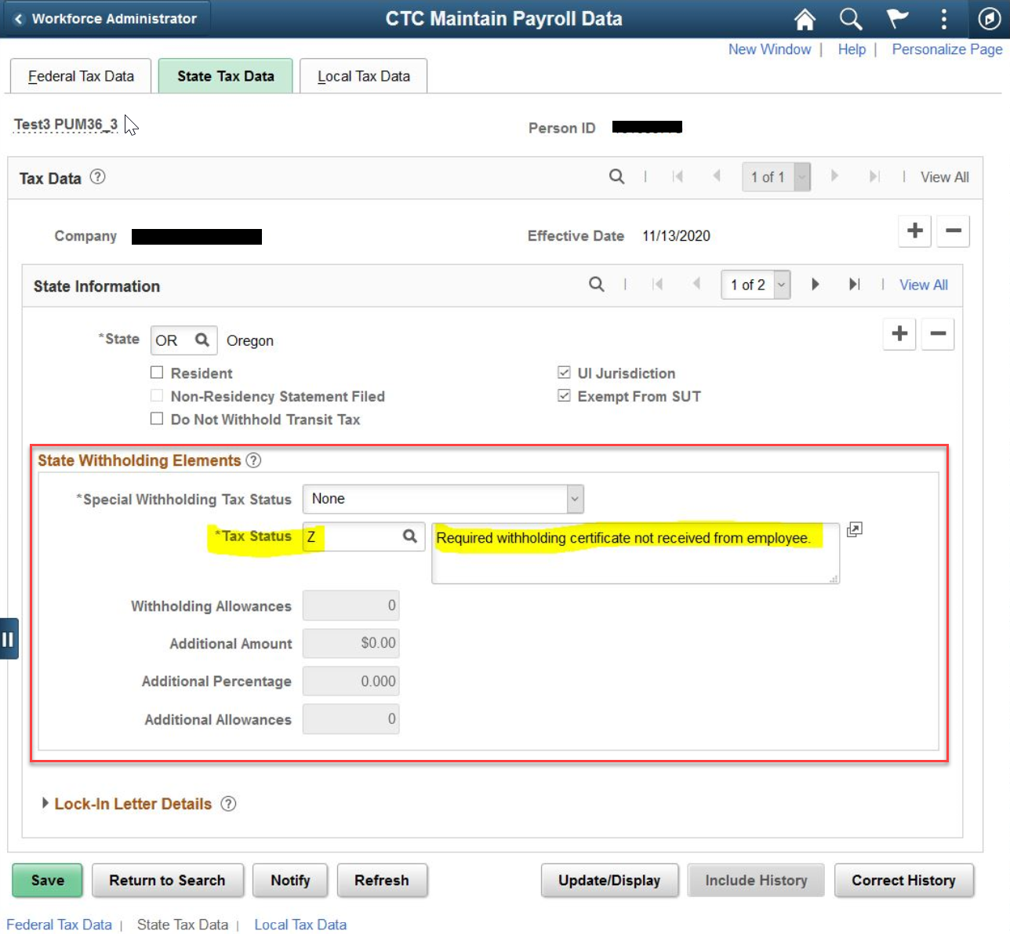

#### QRG

[9.2 Entering U.S. Employee Tax Data](http://ctclinkreferencecenter.ctclink.us/m/79727/l/992872-9-2-entering-u-s-employee-tax-data)

### Updated TAX910ER - Year End Record Error Report

The TAX910ER process has been updated to flag the following error conditions:

* Social Security Tax greater than zero and Social Security Wages and Social Security Tips equal to zero; and
* Medicare Tax greater than zero and Medicare Wages and Tips equal to zero.

Prior to the modifications, these error conditions were not flagged on the report.

#### Navigation to run TAX910ER

NavBar > Navigator > Payroll for North America > U.S. Annual Processing > Audit and Error Reports > Year End Record Error

#### Image: Year End Record Report

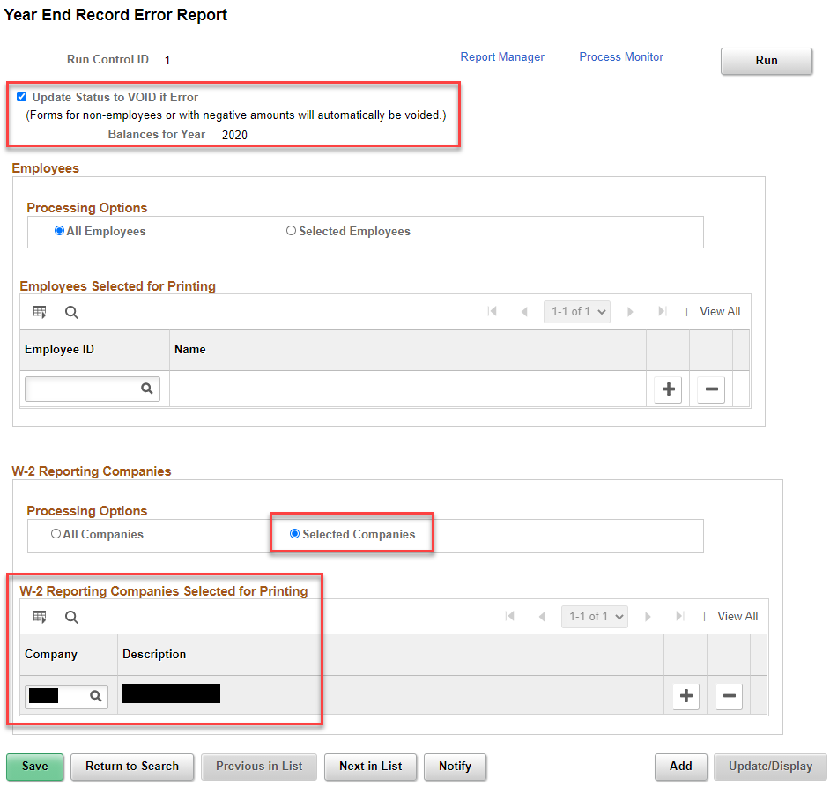

#### QRG

N/A

### Updated Log File Info to Assist in Troubleshooting

Modifications have been made to provide more details on the Log files to assist the payroll administrator in troubleshooting and resolving issues.

The log file displays the Process Parameters (Operator ID, Run ID and Instance) and Processing Options entered on the run control pages for the following processes: Pay Calculation, Confirm, Unconfirm, Reversal, and Reversal/Adjustment.

The log file also displays high level errors on the log file.

#### Image: Calculation log showing high level error message 000014

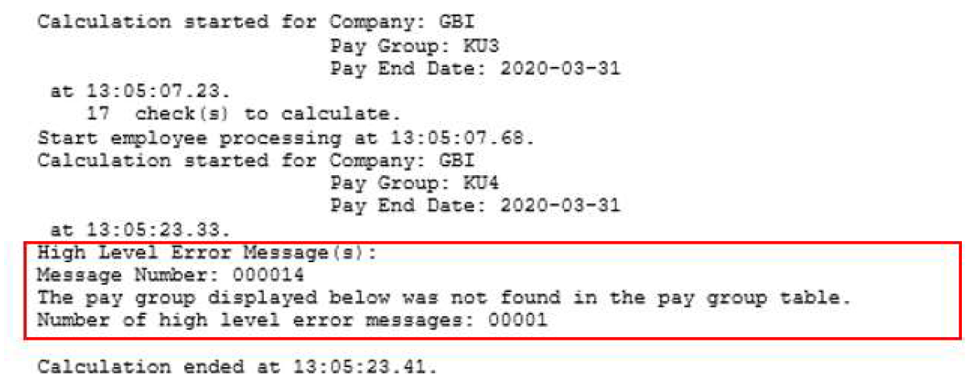The log file continues to display “Check Messages!!!” for employee level errors. Run the Error Report or view the errors online to resolve employee level issues.

#### Image: Calculation Log

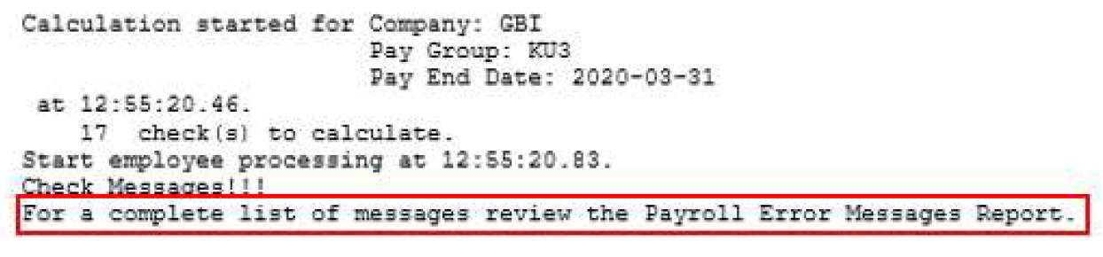Prior to the modifications, the log files showed minimal details entered on the run control page and the number of checks calculated.

### ESS Paycheck/Pay Advice PDF

The processes that generate Paycheck and Advice PDF statements in Employee Self Service have been modified to print “N/A” in the state allowances column on the wage statement for the following states: Arizona, Connecticut, Kentucky, Mississippi, Missouri, Pennsylvania, and Utah.

Prior to the modifications, the state allowances column contained the allowances, if any, listed on an employee’s state tax withholding form.

#### Navigation

Employee Self Service, Payroll Tile, Paychecks – view wage statement PDF

#### Image: Wage Statement PDF Before and After

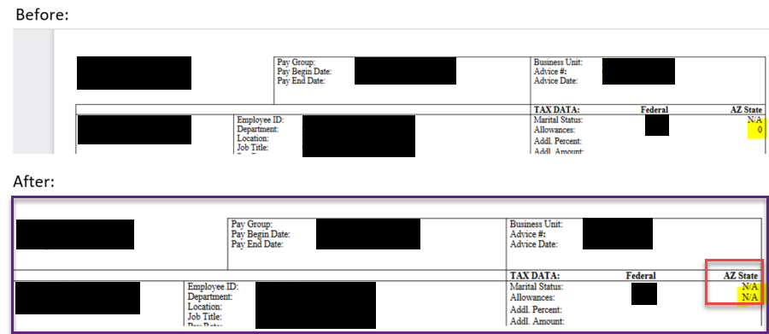

#### QRG

N/A

### ESS W-4 Validation Update

Image 36 includes validations to disable chevron when Special Withholding Tax Status is ‘E’ (No taxable gross, no tax taken) in Employee Tax Data. The employee is restricted from carrying out changes to his/her Federal or State tax data in Employee Self Service.

#### Navigation

Employee Self Service > Payroll Tile > Tax Withholding

#### Image: Tax Withholding

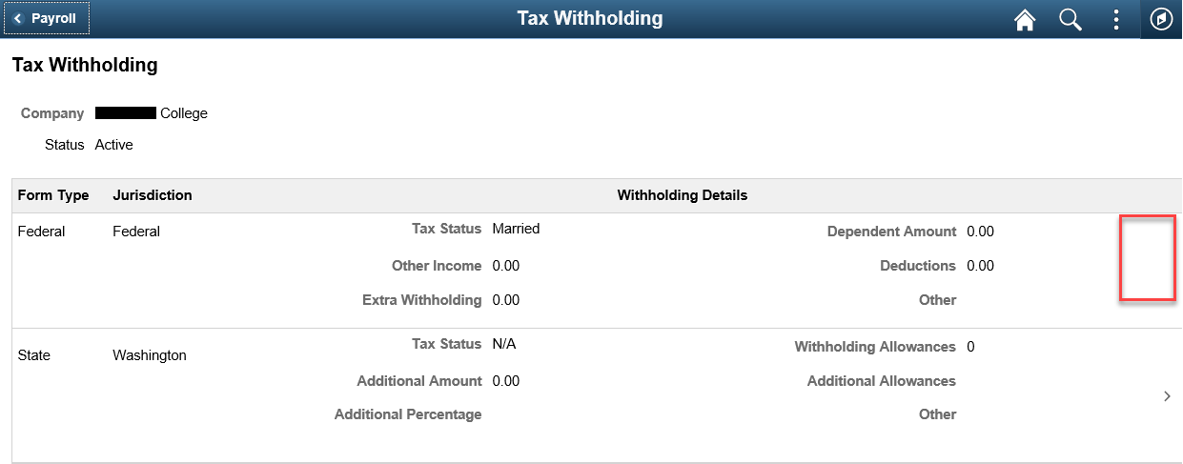

#### QRG

[9.2 ESS W-4 Withholding](http://ctclinkreferencecenter.ctclink.us/m/79746/l/1148386-9-2-ess-w-4-withholding)

### ESS W-4 PDF: Updated AZ A-4

New template for Arizona Form A-4 is delivered, revised for 2020.

#### Navigation

Employee Self Service > Payroll Tile > Tax Withholding

#### Image: A-4 Form

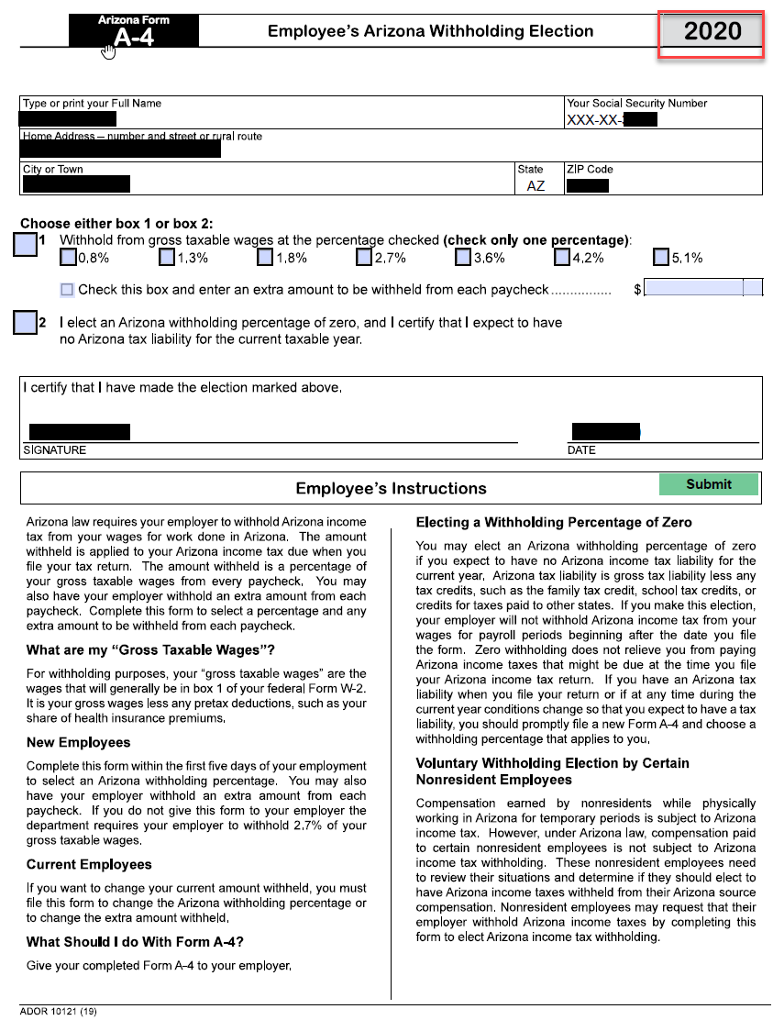

#### QRG

[9.2 ESS W-4 Withholding](http://ctclinkreferencecenter.ctclink.us/m/79746/l/1148386-9-2-ess-w-4-withholding)

### ESS Idaho W-4 PDF

The template for Idaho Form W-4 has been updated to match the latest 06-11-2020 version published by the Idaho State Tax Commission.

#### Navigation

Employee Self Service > Payroll Tile > Tax Withholding

#### Image: Form ID W-4

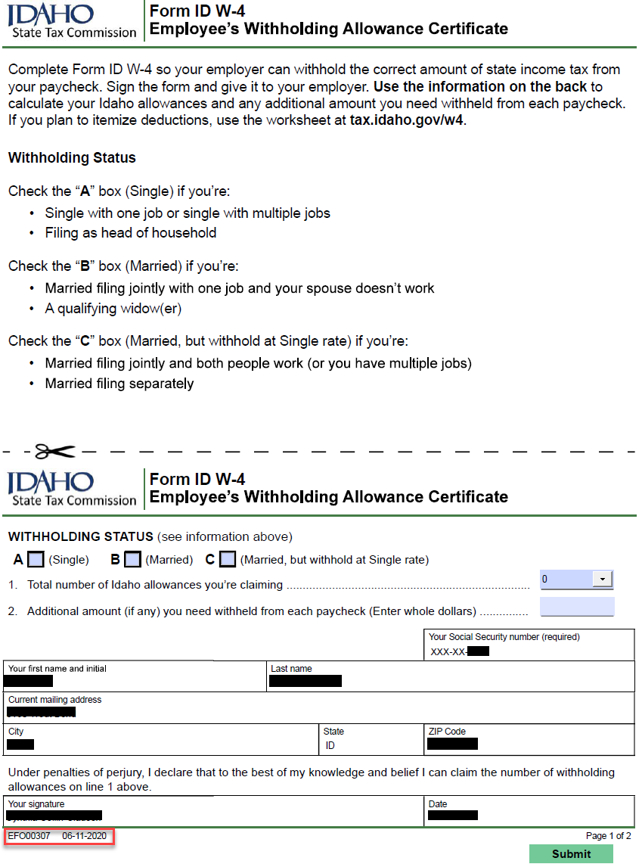

#### QRG

[9.2 ESS W-4 Withholding](http://ctclinkreferencecenter.ctclink.us/m/79746/l/1148386-9-2-ess-w-4-withholding)

### Changes to Paycheck Modeling

Paycheck Modeler modifications will allow the employee to model a check regardless of their W-4 elections in the system. With the new functionality, the employee’s tax elections from their last check is used to calculate the model check. The employee can choose to edit their existing Federal Tax Data elements when creating their model check. When the employees edit the Federal tax data, the Federal Tax Withholding subpage is rendered that supports the Form W-4 2020 elections. Paycheck Modeler is also updated for recent changes to Arizona state tax withholding.

#### Navigation

Employee Self Service > Payroll Tile > Paycheck Modeler

#### Image: State Tax Withholding

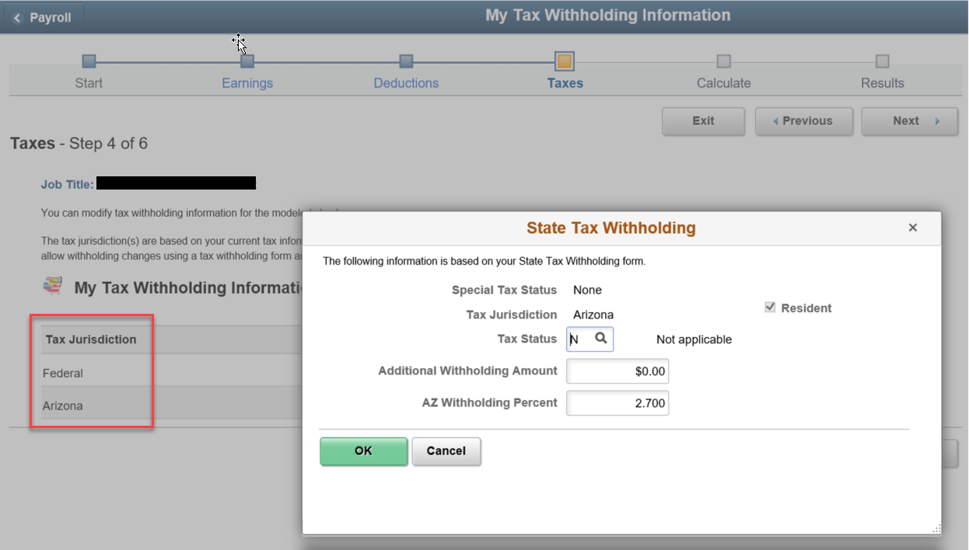

#### QRG

[9.2 ESS Paycheck Modeler (Fluid)](http://ctclinkreferencecenter.ctclink.us/m/79746/l/1017319-9-2-ess-paycheck-modeler-fluid)

### Paysheet Holding Update

Modifications have been made to allow to update Paysheet Holding Update transactions from Status “In Progress” to “Exclude”, in order to exclude them when the process Load Paysheets Transactions is run.

Validation has been added to the custom functionalities Paysheet Holding Load and Paysheet Holding Update (PSHUP_TXN) to prevent invalid Combination Code and Deduction Code entries. Prior to this enhancement Deduction codes with missing Plan Type and/or Benefit Plan could load to the paylines as well as invalid Combination codes.

#### Navigation to Paysheet Holding Load:

NavBar > Navigator > Payroll for North America > CTC Custom > CTC Processes > Paysheet Holding Load

#### Navigation to Paysheet Holding Update:

NavBar > Navigator > Payroll for North America > CTC Custom > Paysheet Holding Update

#### Image: Paysheet Holding Update

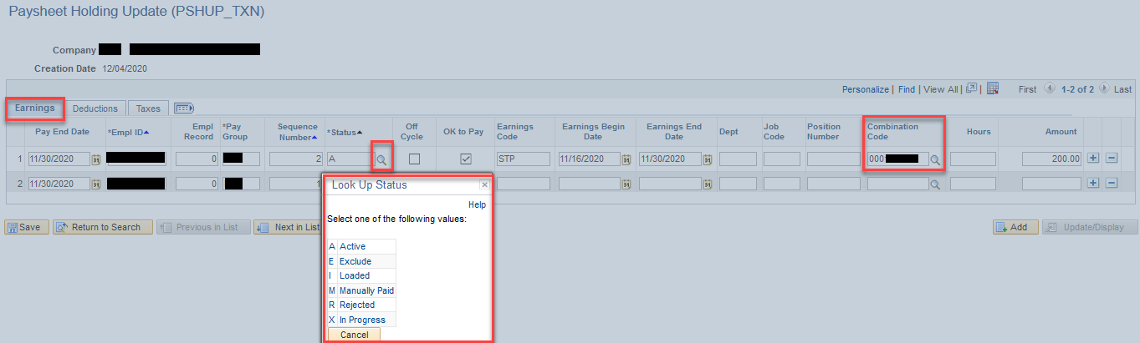

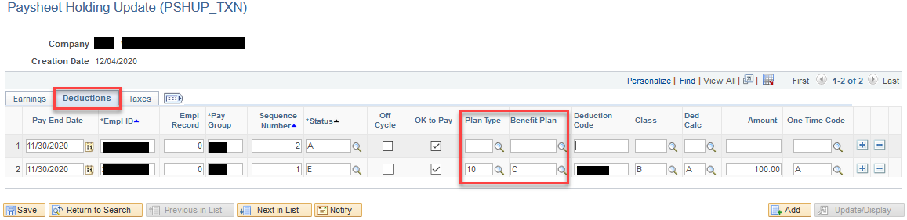

#### QRG

[9.2 One Time PSHUP File Load and Maintenance](http://ctclinkreferencecenter.ctclink.us/m/79727/l/1011696-9-2-one-time-pshup-file-load-and-maintenance)

## Accessibility

### ePay

The system will display an informational message as popup when the user accesses the paycheck summary page. After selecting the OK button on the popup message the screen reader reads “filter toggle button pressed” and also highlights the filter button to indicate the filter is applied.

#### Navigation

Employee Self Service > Payroll > Paychecks

#### Image: Paychecks Tile

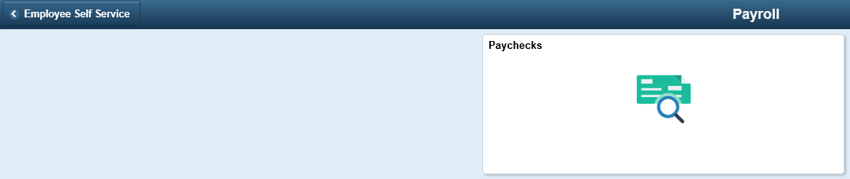

#### Image: Informational Message Popup

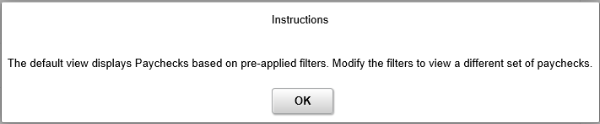

#### Image: Filter Toggle Button

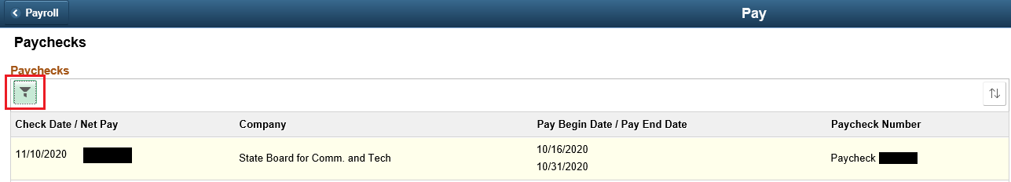

#### QRG

[9.2 Viewing Pay History (Employee Self Service)](http://ctclinkreferencecenter.ctclink.us/m/79746/l/1159876-9-2-viewing-pay-history-employee-self-service)

### MSS - Approvals

Modified style sheet to change the style of view details link.

#### Navigation

Manager Self Service > Approvals

#### Image: Pending Approvals

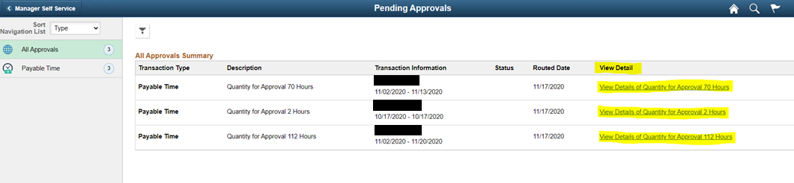

#### Image: Payable Time Details

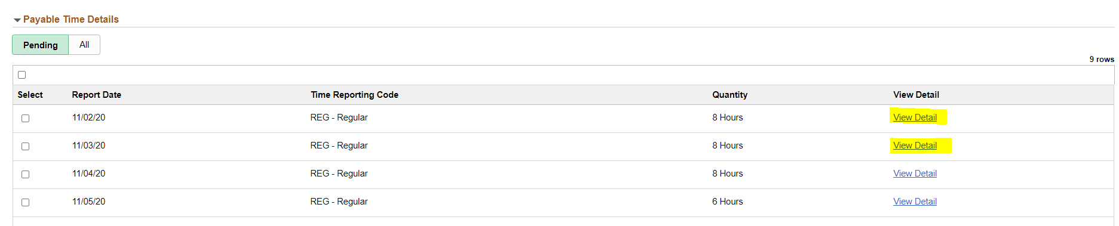

#### QRG

[9.2 MSS Approve Payable Time (Fluid)](http://ctclinkreferencecenter.ctclink.us/m/79748/l/1140693-9-2-mss-approve-payable-time-fluid)

### HR Core

The system was modified to remove the incorrectly marked mandatory fields (phone type, email type, IM protocol, IM domain, and network ID) when in accessibility mode.

#### Navigation

Employee Self Service > Personal Details > Contact Details

#### Image: Personal Details

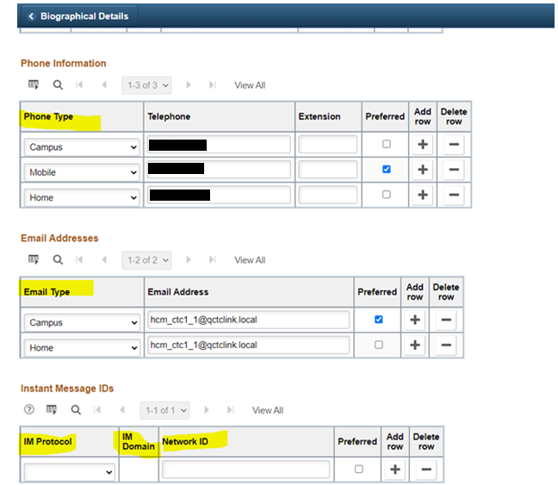

#### QRG

[9.2 ESS Review Personal Information (Fluid)](http://ctclinkreferencecenter.ctclink.us/m/79746/l/1138720-9-2-ess-review-personal-information-fluid)





Content is licensed under a Creative Commons Attribution 4.0 International License, unless noted otherwise.

Washington State Board for Community and Technical Colleges