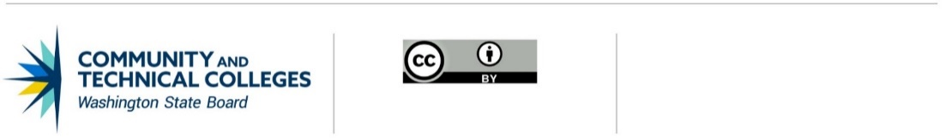

2025-26 Commercial Drivers License & Related Instructional Program Fund (CDL Fund)

Narrative Proposal Attachment
Please provide responses to the sections of this template. Then, save the file using your college name in the file name, and upload as a Word file (docx) to your OGMS funding application. Please do not exceed 4 pages (okay to remove notes written by SBCTC to make space).

COLLEGE NAME:

- Statement of need, goals, and deliverables (outcomes) for the requested funding.

- Instructional program(s) information (insert an additional copy of this table for each instructional program you wish to include in your WA CDL funding application:
Title of program
CIP and ctcLink PLANCODE (see note below)
Credential awarded
Number of credits
If non-credit, please enter number of contact hours.
Maximum number of students (headcount) enrolled per cohort
Number of cohorts currently offered per year
Number of cohorts planned to be offered per year, if this proposal is funded
(Optional) Narrative explanation of any items above to provide necessary context or details.

Notes: For projects that target credit-bearing professional-technical program(s), the program(s) must either be on your current professional-technical program inventory or a Notice of Intent has been submitted no later than to the proposal deadline.
All WA CDL courses and enrollments must be set up in ctcLink. Courses associated with credit-bearing programs must be set up in UGRD and non-credit courses may be set up in CNED. Each course must be coded with an allowable CIP code (see Program Guidelines, page 9).
For UGRD programs, please provide the ACAD_PLAN, the CIP code on the ACAD_PLAN, and number of credits for each program.
For CNED courses, please provide the Subject, Catalog Number, course CIP code, and course contact hours for each course.
- Timeline identifying major milestones/activities for the 2-year period of FY26 and FY27.
Note: All equipment procurements proposed for a given fiscal year must be completed no later than June 30 of that year, with no exceptions or extensions. Items that require a long procurement process can include planning in year one and expenditure in year 2. Note that funding availability year 2 is contingent on continued state funding.
- Describe any leveraged resources supporting the proposal.
Note: In alignment with statewide goals to leverage public/private investments, proposals with higher leveraged resources from private industry receive priority for funding. Examples of leveraged resources include, but are not limited to, the contribution of time, space, materials/consumables, equipment and/or tuition resources made by private industry, external partners or institutional/foundation resources to directly meet proposed outcomes.
- Consortium proposals only:
- Identify the lead institution, including name and position of lead point-of-contact.
- List all consortium members, including the names and positions of each college’s lead point-of-contact.

