**VANCOUVER –**The 2024 AWB Manufacturing Week bus tour kicked off Wednesday with visits to manufacturers in Kalama, Yakima, and the greater Vancouver area.

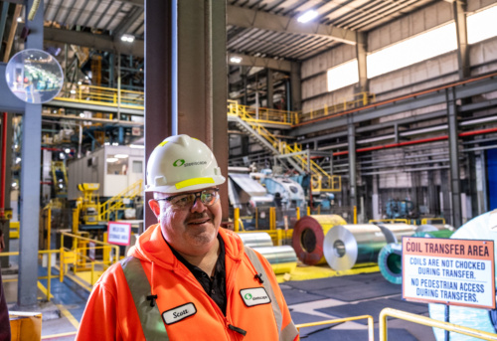

*Scott Cooley, general manager of Steelscape, has worked 22 years at the company and 32 years in the steel industry overall. He said when he began working in steel out of college, old-timers told him, “your blood’s gonna rust. It’s gonna get into your blood. I’ve never done anything other than steel. It’s a great industry, great customers.”  (Photo: Brian Mittge/AWB)*

Employees were invited to sign the AWB bus on the first day of the annual cross-state tour to celebrate Washington’s manufacturing sector. The six-day tour, sponsored by Premera and Banner Bank, runs through Oct. 9 and includes stops at 25 manufacturing plants and training centers statewide.

Cowlitz County

The day began at the Port of Kalama with tours of **Steelscape** and the **TEMCO grain terminal**.

Steelscape makes galvanized painted steel for the construction industry. Its products are found in the exteriors and walk-in freezers of Costco stores, the Apple headquarters, and roof of the McMenamins Kalama Harbor Lodge.

“It’s exciting, seeing where our products end up,” said Scott Cooley, general manager of Steelscape, who has been with the company for 22 years.

Steelscape employs 260 and about 20% of the workforce is women. The company continues to invest in automation to aid with heavy and repetitive tasks, plant manager Mick Rompa said.

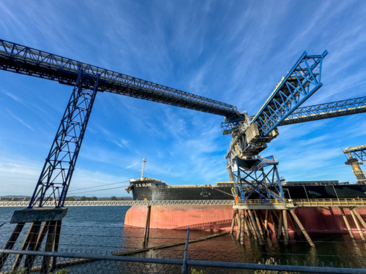

*The TEMCO terminal in the Port of Kalama is a joint partnership of CHS and Cargill. It has 6.5 million bushels of grain storage capacity in the steel towers visible from I-5. AWB’s Manufacturing Week tour visited on the day that it was unloading its first soybeans of the season coming in from North Dakota and other states by rail, to be loaded onto a boat for export to China.*

The TEMCO grain terminal, a joint venture between CHS and Cargill, ships grain from a dozen states all over the world, supporting 25 full-time jobs. On Wednesday, workers were busy loading a rail shipment of soybeans from the Midwest onto a ship bound for China.

Businesses at the port employ 1,400 people. Other manufacturers include makers of wine bottles, sourdough bread, aerospace parts, food packaging, lumber and log homes, and brewers and distillers.

The tour also learned about the student-run store at the port’s Mountain Timber Market. All goods sold there are designed and manufactured by Kalama High School students.

In Cowlitz County,[manufacturers employ](https://www.awb.org/wp-content/uploads/2024-AWB-MFG-Week-one-pager.pdf) 7,373 people and pay an average wage of $82,413.

Clark County

Next up was**Wolf Industries**,a manufacturer of small modular homes in Battle Ground.

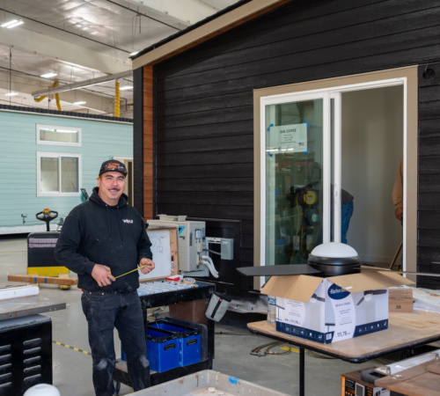

*Wolf Industries, founded in 2008, has a facility in Battle Ground that can build a custom modular tiny home in just 12 days.*

“We do everything from A to Z,” said CEO Derek Huegel, who founded the company in 2008. Wolf Industries takes care of the permitting, site work, construction and set-up of its tiny homes, which range from 300 to 1,200 square feet. It manufactures a home in 12 days start to finish.

Wolf Industries, which employs 90, is on track to build a record 120 homes this year. As housing demand exceeds supply, smaller homes can expand options, said employee Ron Barca. “It’s actually what drove me to want to get into the business was the idea of affordable housing,” he said.

The tour also visited **TigerStop, LLC** in Vancouver. Founded in 1994, the company makes automation equipment, specifically saws and positioning equipment, to empower other manufacturers to be globally competitive. It employs 50 people.

“We manufacture equipment that makes other manufacturers be able to do their jobs more effectively,” said TigerStop Vice President Nathaniel Dick, the second generation of the family business. “And that gives us a lot of satisfaction.”

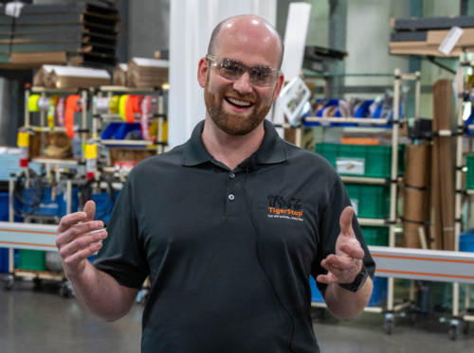

*Tigerstop, LLC Vice President Nathaniel Dick gives a tour to AWB members and other employer advocates.*

The company is proud to source 100% of its materials domestically, including up to 90% from the Pacific Northwest. TigerStop is a finalist for AWB’s Manufacturing Excellence Award for Innovation. The winner will be announced Nov. 21 at AWB’s annual Evening of Excellence ceremony.

Clark County manufacturers support 14,334 jobs and pay an average wage of $74,517. The county is home to the state’s fifth largest manufacturing workforce.

Yakima County

Day one concluded in Yakima at **Adventurer Manufacturing**, which makes slide-in truck campers and motorhomes. The company was founded in British Columbia in 1969 and moved its manufacturing facility to Yakima in 2008. It has 135 employees.

This summer, the company opened a new facility in Union Gap, called the Advanced Panel Operations Center, aiming to optimize efficiency and incorporate lean manufacturing principles.

*Adventurer Manufacturing Vice President of Operations Claus Schroeder and AWB President Kris Johnson with a TigerStop measuring and cutting tool at Adventurer Manufacturing’s new production facility, opened this spring.*

“I’ve been doing this for 30 years and have seen a huge improvement in processes,” said Mario Mendoza, the production and facilities manager for Adventurer. Adventurer Manufacturing is a finalist for AWB’s Manufacturer of the Year Award.

In Yakima County, manufacturers employ 8,101 people and pay an average wage of $58,514.

*Elias Aguayo, a senior at Kennewick High School, toured Lampson International with AWB’s Manufacturing Week bus tour. He appreciated the chance to see trades work up close. “It sounds like it would be a good path if I decide to go that direction,” he said. (Photo: Brian Mittge/AWB)*

Tri-Cities

The day began in Kennewick at crane manufacturer **Lampson International,**where AWB President Kris Johnson delivered his [second annual State of Manufacturing address](https://www.awb.org/awb-delivers-2024-state-of-manufacturing-address/).

Johnson highlighted the strengths and challenges of the state’s manufacturing sector, noting manufacturers’ key priorities for the 2025 Washington legislative session. .

Twenty high-school students from the Tri-Tech Skills Center toured Lampson’s plant in Pasco, exploring careers in manufacturing.

Richland-based **OCOchem** is developing and scaling technology to turn carbon dioxide into useful chemicals. Todd Brix founded the company in 2020, starting with two employees. It has grown to 17 strong and operates the world’s largest CO2 electrolyzer.

*OCOchem has built and operates the world’s largest CO2 electrolyzer in Richland.*

For every pound of product OCOchem makes, roughly 7 pounds of CO2 emissions are abated, making carbon regeneration seven times more effective than CO2 sequestration, the company says.

In Benton and Franklin counties, [manufacturers employ](https://www.awb.org/wp-content/uploads/2024-AWB-MFG-Week-one-pager.pdf) a combined 9,500 people, with an average wage ranging from $58,000 to $68,000.

Walla Walla County

Next up was the **Tri-Cities Intermodal**facility in Wallula, where cargo is moved between truck and rail. Since opening in 2023, Intermodal has become a global shipping hub, moving everything from peas and lentils to Amazon products.

The intermodal ramp moves goods both east and west, handling imports and exports at a lower cost and with fewer emissions. Terri Zimmerman, vice president of sales and marketing, said the facility reduces truck traffic on Snoqualmie Pass and congestion at ports.

In Walla Walla County, manufacturers employ 3,918 people with an average wage of $65,291.

Pullman

*AWB President Kris Johnson speaks as Leith Sorenson, senior vice president of manufacturing for Schweitzer Engineering Laboratories, looks on.*

Day two ended at **Schweitzer Engineering Laboratories** (SEL) in Pullman. Since starting in a basement in1984, SEL has become a global leader in electric power systems, with a mission to make power safer, more reliable and more economical.

“All of our devices we produce are produced here in the U.S. and we ship them all over the world,” including to 171 countries, said Leith Sorenson, senior vice president of manufacturing for SEL.

The Pullman factory – with 2,300 employees – is the company’s largest nationwide. The second largest operates in Lewiston, Idaho. SEL is 100% employee-owned and offers benefits such as on-site health clinic.

Schweitzer Engineering Laboratories is a finalist for AWB’s Manufacturer of the Year Award. The winner will be announced Nov. 21 at AWB’s annual Evening of Excellence ceremony.

In Whitman County, manufacturers employ 2,941 people with an average wage of $87,826.

Spokane County

The first stop of the day, **Altium Packaging**in Spokane Valley, employs 35 people to make plastic packaging for the dairy, beverage, health care, personal care, automotive and industrial chemical industries.

In 2023, the Spokane plant used more than 400,000 pounds of recycled plastic to produce its bottles, keeping plastic out of landfills and turning it into new products. Altium Packaging is a finalist for AWB’s Manufacturer of the Year Award.

Next up was **Knife River Prestress**, a national leader in the precast and prestressed concrete industry. Last year, it opened a massive, state-of-the-art new plant in Newman Lake, just west of the Washington-Idaho border. It employs 90 and plans to grow.

*A wall for the new Washington State University bioscience research center comes to life, complete with thin brick exterior placed by hand, at Knife River Prestress.*

At the nearly 200,000-square-foot facility, workers prefabricate components for bridges and buildings in a controlled indoor environment. The company recycles water used in manufacturing and captures dust from operations.

Knife River Prestress is a finalist for AWB’s Manufacturing Excellence Award for Innovation. The company’s work can be found in Climate Pledge Arena, Google and Meta campuses, and data centers and bridges around the region. “If it’s a concrete bridge, it’s likely we built it,” said Knife River Commercial Director Blake Johnson.

The bus also went to **Spokane Community College** to highlight the college’s manufacturing programs. Enrollment is growing as the college continues to emphasize opportunities in modern manufacturing, leaders said.

*Cadence Haskins talks about her experience studying hydraulics and mechatronics at Spokane Community College.*

Cadence Haskins, a student in her final quarter of the robotics and mechatronics program, spoke with a group of East Valley High School students who joined the tour. Haskins said she wanted to study engineering without pursuing a four-year degree.

“I wanted options to work right away,” Haskins said. “The great thing about this program is every single quarter we get at least one employer begging us to come work for them. The skills you get in this program are in high demand.” She has completed two internships and has a job lined up.

The tour also visited the **Jubilant HollisterStier and HollisterStier Allergy**production facility in Spokane. The company specializes in the manufacturing of sterile injectables, allergy immunotherapy products and other pharmaceutical products, and contract manufacturing services.

Jubilant is in the midst of a huge expansion, doubling the Spokane facility to 315,000 square feet. The company was founded in 1921 and was acquired by Jubilant Life Sciences in 2007. It has 936 employees and is hiring more.

Jubilant HollisterStier is a finalist for two AWB Manufacturing Excellence Awards: the Manufacturer of the Year Award and the Operational Excellence Award.

Spokane County manufacturers [employ](https://www.awb.org/wp-content/uploads/2024-AWB-MFG-Week-one-pager.pdf) 16,482 people and pay an average wage of $69,401. The county is home to the state’s fourth largest manufacturing workforce.

Moses Lake

*The J.R. Simplot Company invented the frozen French fry and sold the first frozen fry to McDonald’s in the 1960s.*

The day ended at the high-tech potato processing plant of **J.R. Simplot Company**. Founded in 1929 by the company’s namesake, J.R. Simplot has grown into a global enterprise with 17 manufacturing plants and 10 potato factories worldwide.

The Moses Lake plant, which employs 255, makes the shoestring French fries sold at McDonalds and other fast food restaurants, plus tater gems, hash browns and other frozen potato products. It sources potatoes primarily from Washington farmers.

Simplot has made improvements to become more sustainable, operating an anaerobic digester to turn waste into biogas fuel. It is building a new Moses Lake processing plant to support 150 new jobs, plus a 14-story freezer with capacity for 65,000 pallets.

In Grant County, manufacturers employ 4,531 people with an average wage of $68,759.

Thurston County

The day began at **Callisons**, a Lacey manufacturer and leading supplier of mint oil for the oral care and confectionary industries. Founded in 1903, the company provides mint flavors to customers around the world.

At Callisons, mint oil is blended, purified and prepared for shipment overseas. Inside one 55-gallon drum is enough mint oil to flavor 5.2 million sticks of gum and 350,000 tubes of toothpaste, company leaders said. The mint is grown at farms throughout the Pacific Northwest and the world, and harvested over the summer. Washington state leads the country in mint oil production.

In Thurston County, manufacturers [employ](https://www.awb.org/wp-content/uploads/2024-AWB-MFG-Week-one-pager.pdf) 3,273 people and pay an average wage of $64,822.

Pierce County

Next up was **Sutter Metals Recycling** a leading recycler of everything from cars and copper to old computers and aluminum cans. The family-owned company, founded in 2009, employs 57 people and is headquartered in south Tacoma in a new facility the company built in 2020.

“Our main focus is to help the environment and keep as much material out of the landfill as possible,” co-owner Chad Sutter said. “It has a massive impact and benefit on our environment.”

AWB also toured the **SAFE Boats International**production facility at the Port of Tacoma. Founded in 1996, SAFE Boats has built 2,600 boats for more than 70 countries, specializing in search and rescue and boats, U.S. Navy and Coast Guard vessels. It is currently building boats for the Ukrainian Navy.

“Business is absolutely booming,” said Christer Bradley of SAFE Boats, noting the company is looking to hire more employees.

Pierce County manufacturers employ 16,537 people and pay an average wage of $74,896.

King County

The bus also visited the **PACCAR** Kenworth plant in Renton, where 518 employees manufacture heavy-duty commercial trucks that deliver goods across America and the world.

The company originated in Washington and has been in business for 101 years. It produces 17 models of Kenworth trucks, all custom made-to-order.

**Harper Engineering**in Renton was the last stop of the day. OJ Harper founded the company in 1968 with a vision to address technical challenges in aircraft interiors. Today, the company of 80 employee-owners is a leading supplier of “small parts on big airplanes,” like the latches and hinges that hold together aircraft doors and overhead bins.

“We do everything we can to make sure we deliver perfect parts on time,” said Ryan Funk, senior manager of special projects for Harper Engineering.

Boeing has recognized Harper Engineering twice with a Supplier of the Year Award, most recently in 2023 for the company’s commitment to customer service and on-time delivery.

King County manufacturers employ 92,828 people and pay an average wage of $110,379.

King County manufacturers [employ](https://www.awb.org/wp-content/uploads/2024-AWB-MFG-Week-one-pager.pdf) 92,828 people and pay an average wage of $110,379.

The day began at **Lighthouse for the Blind,**a non-profit social enterprise providing employment, support, and training opportunities for people who are blind, DeafBlind, and blind with other disabilities. It manufactures aerospace parts, Skilcraft products, military canteens, hydration bladders and other products, employing 300 people in Seattle.

“The unemployment or underemployment rate for people or who are visually impaired is about 70%,” said George Abbott, president and CEO of Lighthouse for the Blind.  “The number has not changed much in decades.”

*Ash Grove recently acquired Spot, a Boston Dynamics robot that can climb stairs, pick itself up if it falls over, and is equipped with cameras and heat sensors to take readings in places that are difficult for humans to access.*

Lighthouse also provides mobility services to teach independent travel with a cane or dog guide and over 100 computer accessible workstations. In its machine shop, 100% of equipment can be used by employees who are blind or deaf.

AWB also visited **Ash Grove Cement,** which operates the only integrated cement plant in Washington state. Founded in 1920, the company employs 70,000 globally and 100 at its Marginal Way plant in Seattle.

Ash Grove produces about 2,000 tons a day of finished product to construct highways, bridges, homes and commercial and industrial buildings. At the same time, the company processes about 1.2 million used tires – which would otherwise end up in a landfill – into a fuel substitute.

The tour continued at **Wave Motion Launch Corporation**, a Seattle startup founded in 2020. Wave Motion manufactures a proprietary launcher system known as the Jet Gun, “the most compact means of firing a projectile the world has ever seen,” the company says.

The three-person company serves as a prime contractor on Department of Defense contracts and ultimately hopes to use the Jet Gun to conduct non-rocket space launch.

Next up was **McKinstry**, a national construction and energy services company focused on improving energy efficiencies in buildings and reducing waste. The Seattle facility makes ductwork and piping materials for direct installations into buildings. “We work to engineer and design buildings and buildings systems that do not harm the environment,” the company says.

*James Penna, chief operating officer and co-founder of Wave Motion Launch Corporation, gave a tour and introduced the company’s employees to AWB’s Manufacturing Week bus tour.*

In Woodinville, AWB toured **Modern Hydrogen**, which manufactures clean hydrogen generation technology. The startup takes natural gas and biogas and splits it into solid carbon and hydrogen fuel. The clean hydrogen fuel is used in industrial operations, manufacturing, fuel cells for cars and trucks, and other applications.

“It’s very motivating; it’s nice to do something that is meaningful,” said Nik Sears, a Modern Hydrogen employee of three years. “We’re making cleaner and cheaper energy.”

Modern Hydrogen also came up with an innovative use for its carbon byproduct. It adds the solid carbon to asphalt, which traps the carbon while replacing fossil fuel-based asphalt materials, while making roads stronger.

The tour ended with visits to manufacturers in Woodinville’s Warehouse District, a hub for working wineries.

**Page Cellars** was founded in 2000; Dee and Todd Krivoshein became the new owners in 2021. While its grapes are grown in Eastern Washington, all the wine is made on-site in Woodinville.

*Max Mankin of Modern Hydrogen gives a tour of the company’s R&D facility in Woodinville.*

The winery sources grapes from Red Mountain, a wine region of fewer than 5,000 acres in the Columbia Valley. The unique region has a large variation between high and low temperatures, producing concentrated flavors. “It’s hot during the day and the temperatures cool dramatically enough to cause a differential that the grapes really love,” said Meghan Parris, business and tasting room manager**.**

Next door is **Washington Creek Distillery**, which opened its doors in August and makes distilled spirits, vodka, liqueurs, bourbon and whiskey. Last week, Washington Creek Distillery bottled its first batch of five-year aged bourbon.

Skagit County

*From field to flour at the Cairnspring Mills flour production facility in Burlington. AWB visited the site on Wednesday, Oct. 9, the sixth and final day of the eighth-annual Manufacturing Week bus tour. (Photo: Brian Mittge/AWB)*

AWB visited**Cairnspring Mills,**a small craft flour mill established in 2016 at the Port of Skagit in Burlington. The tour got a behind-the-scenes look at the operation, where wheat is received, dried, cleaned and conditioned to increase moisture content. It is then rolled and processed to preserve nutrients.

“We’re keeping 85 to 90% of the bran in – we’re not removing any of the nutrients,” said Dave Binczewski, production mill and granary manager for Cairnspring Mills.

Cairnspring sources between 75% and 80% of its wheat from Skagit Valley growers. The mill began as a collaboration between local farmers, economic development leaders and bakers with several goals: help farmers remain economically viable, shorten the distance between farmer and customer, and build healthy soil and conserve farmland. The mill employs 20.

Cairnspring Mills is a finalist for the AWB Manufacturing Excellence Award for Innovation.

Skagit County manufacturers [employ](https://www.awb.org/wp-content/uploads/2024-AWB-MFG-Week-one-pager.pdf) 5,731 people and pay an average wage of $76,205.

Snohomish County

The **Washington Aerospace Training & Research (WATR) Center**, part of Edmonds College, prepares students for in-demand jobs in aerospace, construction, maritime, automation and robotics. The 12-week program is a hybrid model, with four weeks online and 8 weeks of hands-on training.

Sheila Dersham, associate director of the WATR Center, said the college learned employers were looking for workers with specific skills rather than degrees. “We set up a program that concentrates on those specific work skills, safety, and all those foundational things you have to learn when you start your first job,” she said.

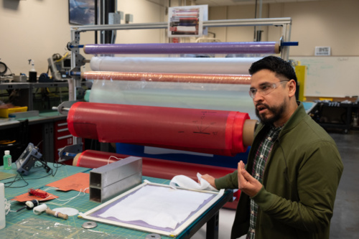

*At the Washington Aerospace Training & Research Center (WATR) in Everett, students learn the skills required for a high-wage, high-demand manufacturing job in just 12 weeks, including carbon fiber (as demonstrated here).*

AWB also visited the **Advanced Manufacturing Training and Education Center (AMTEC)** at Everett Community College, a 54,000-square-foot, state-of-the-art center where students train with the latest manufacturing technologies.

AMTEC also offers a Registered Apprenticeship Program through the Washington Department of Labor & Industries, graduating more than 100 apprentices in 14 years. “It’s a great way to bring the young generation into the trades,” said Mark Jackson, apprenticeship coordinator for Nichols Bros. Boat Builders.

The bus headed north to **Himalayan Pet Supply,**an Arlington manufacturer that uses an ancient Nepalese recipe to make hard cheese chews for dogs.

It began in 2003 when co-founders Nishes Shrestha and Suman Shrestha met for dinner. Suman noticed Nishes’ dog chewing on a piece of Churpi – Himalayan hard cheese that is preserved using centuries-old techniques. The two were inspired to use the same technique to make a high-quality chew for dogs, re-engineered to be free of lactose and fat.

The company of roughly 140 employees is multicultural, with 23 countries and 15 languages represented. It works with thousands of farmers in Nepal to give back to the community.

Himalayan Pet Supply is a finalist for the AWB Manufacturing Excellence Award for Innovation.

*U.S. Rep. Kim Schrier talks with Toolcraft, Inc. Founder and President Karl Niemela during AWB’s Manufacturing Week tour of his facility in Monroe.*

The final stop was **Toolcraft, Inc.**in Monroe. Founded by Karl Niemela in 1990, Toolcraft specializes in making small, precise parts for the aerospace, space, medical and defense industries.

Two generations of family work at the company and the team of 60 has an average age of 32. “It’s very rewarding and fulfilling,” said Myra Niemela, 19, the parts finishing supervisor at Toolcraft and daughter of founder and president Karl Niemela.

Toolcraft is a finalist for the AWB Manufacturing Excellence Award for Operational Excellence.

Snohomish County manufacturers [employ](https://www.awb.org/wp-content/uploads/2024-AWB-MFG-Week-one-pager.pdf) 53,878 people and pay an average wage of $115,666.