**Select if you will be attending both days or one of the two**

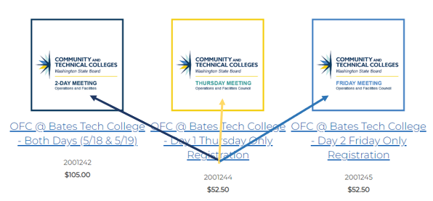

**Select “No Preference” if you have no food restrictions or “Vegetarian” if you require a vegetarian option. Then select “save”**

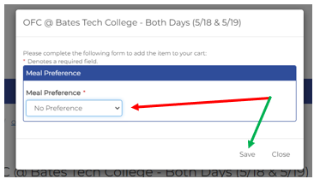

**Select Payment Options**

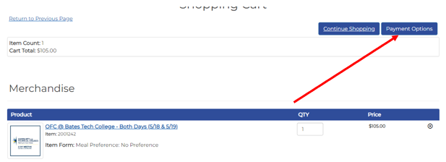

Select Pickup Order so there is no shipping charge

