PCard Review

There is an inherent risk in the PCard module. Users with the role CC_Administrator have access to see the full card number for all purchase cards in the system. They also have access to code transactions and mark them as approved. In theory, a user with the CC_Administrator role could use any card in the system for a personal purchase, code it themselves, and mark it approved themselves. To help protect against this abuse, the purchasing department reviews all card transactions each statement cycle. They review the attached documentation and coding to ensure purchases are appropriate.

However, the individuals who perform this review also have the CC_Administrator role. The following process is completed in the business office monthly to mitigate that risk.

# Determine Dates to Review

* Navigate to the Procurement Card Folder on the Purchasing SharePoint site
  + <https://yvcc.sharepoint.com/sites/Purchasing/Internal%20Documents/Forms/AllItems.aspx?id=%2Fsites%2FPurchasing%2FInternal%20Documents%2FProcurement%20Card&viewid=f5b1d5d5%2D1370%2D4c85%2Dbc69%2Dae7246afc61f>
* Open the “PCARD Deadlines” pdf file for the current fiscal year
* If reviewing for period 2, for example, identify the last statement close date for period 1
* The review period will begin the calendar date following that statement close date
  + In the example below, the last statement close date for period 1 is 7/19/24, so the review period begins 7/20/24
* Again, if reviewing period 2, identify the last statement close date for period 2; that will be the end date for the review period
  + In the example below, the last statement close date for period 2 is 8/30/24, so the review period ends 8/30/24

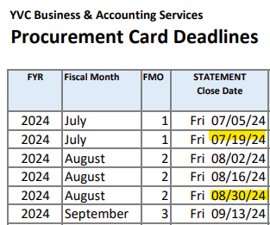

# Running the Report

* Run the QFS_EX_PCARD_TRANS_CHRTFILD query
  + Unit: WA160
  + Posted Date From: As determined above
  + Posted Date To: As determined above
  + Status: 4 (or select closed from the looking glass)
  + PCard Account: Leave Blank

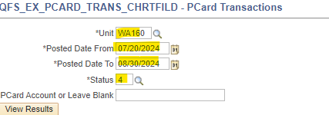

* Download results into an Excel Spreadsheet

# Reviewing the Report & Transactions in ctcLink

* Apply a filter to the resulting data
* Filter the “approved by” column to the individuals in the purchasing office with the CC_Administrator role
  + Currently those are:
    - #########
    - #########
* Copy those rows to a new tab in the workbook
* Name this tab “Review”
* Return to the results
* Filter the “last user to modify” to those same individuals
* Filter out any transactions approved by either the director or assistant director of business & accounting services, as these items have already been reviewed
  + Currently those are:
    - #########
    - #########
* Select a random sampling of no fewer than 10 transactions and at least 10% of the total count of filtered transactions
* Copy the random sampling to the “Review” tab

# Reviewing Transactions in ctcLink

* In ctcLink, navigate to Menu/Purchasing/Procurement Cards/Reconcile/Reconcile PCard Statement
* Search for each transaction in the query approved by those individuals
  + Clear the Transaction Date
  + Copy the Tran Nbr from the query and paste in the “Transaction Number” field
  + Change the “Statement Status” to “Closed”
  + Click Search



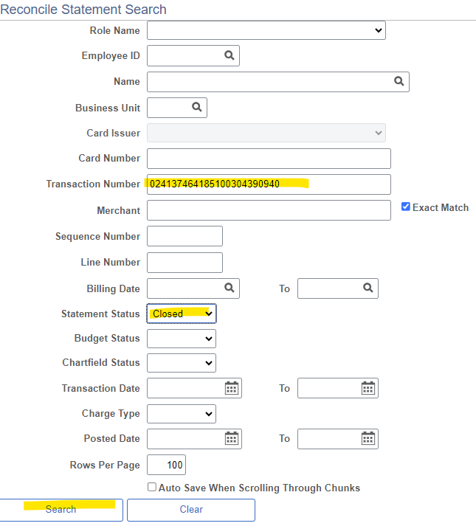

* Click the speech bubble to open the attachments

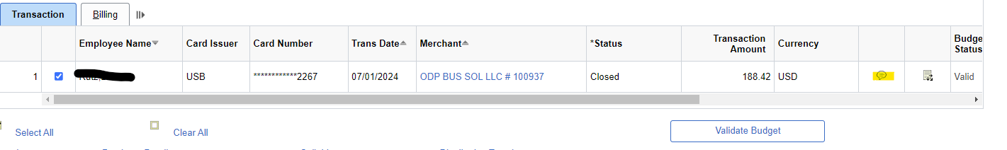

* Click View to open the attachment

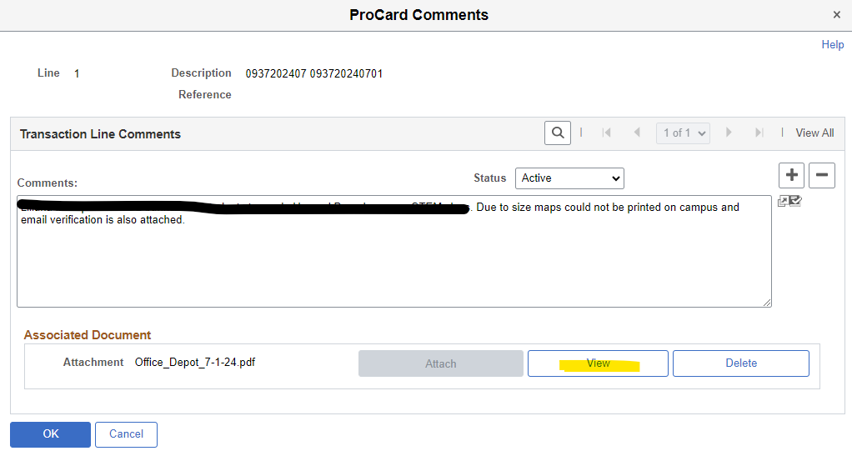

* Review the receipt to ensure it is appropriate
  + Look for items such as:
    - Delivery address, must be YVC
    - Account name, if applicable, must be YVC
    - Details of items purchased to ensure they match the comments
    - Amount on receipt matches charge amount
    - Any other backup that would substantiate the charge is legitimately a YVC expense
* Add a column to the right of all the data on the “review” tab for Notes
  + Document what was reviewed that either identified a concern or made the charge seem reasonable.
  + If there are concerns that a purchase is not appropriate, report to the Director of Business & Accounting Services, who will escalate as needed to VP of Administrative Services and/or Human Resources
* Once all items are reviewed, make a note at the bottom of the spreadsheet documenting overall review such as:
  + “All reviewed transactions appear reasonable. No concerns identified.”
  + “Concerns on several transactions. Reported to Director on 1/6/25.”
* Save the file in the folder for the current fiscal year
  + \\yvccnas\departments\Business Office\Business Users\Accounting\Director - Angela\PCard Review
* Title it “Period # - reviewed MM-DD-YY”