ATC Treasurer Report
Winter Quarter 2024

Expenses and Revenue
18 colleges paid as of 1/23 ($2,700)
16 colleges outstanding (below)

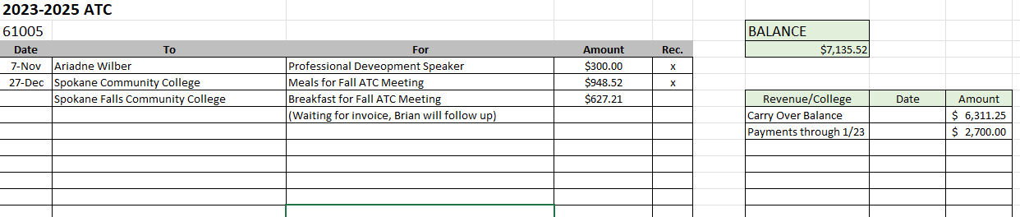

For outstanding dues invoices, you can call the phone number on the invoice to pay by P-Card. (Shown below.)
If you need the invoice resent or want to check the person the invoice went to, email brian.palmer@seattlecolleges.edu

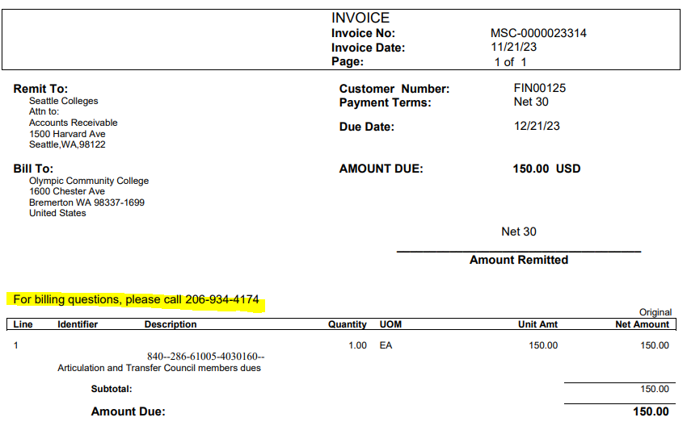

Dues are Due:

Bates Technical College | MSC-0000023290
Cascadia College | MSC-0000023295
Centralia College | MSC-0000023296
Clover Park Technical College | MSC-0000023298
Edmonds Community College | MSC-0000023301
Grays Harbor College | MSC-0000023303
Pierce College Fort Steilacoom | MSC-0000023319
Pierce College Puyallup | MSC-0000023320
Renton Technical College | MSC-0000023323
Skagit Valley College | MSC-0000023326
South Puget Sound Community College | MSC-0000023328
Spokane Community College | MSC-0000023330
Tacoma Community College | MSC-0000023334
Walla Walla Community College | MSC-0000023336
Wenatchee Valley College | MSC-0000023337
Whatcom Community College | MSC-0000023338

